**Noteguide for Centripetal Acceleration (Videos 5A) Name**

Velocity = Speed + Direction

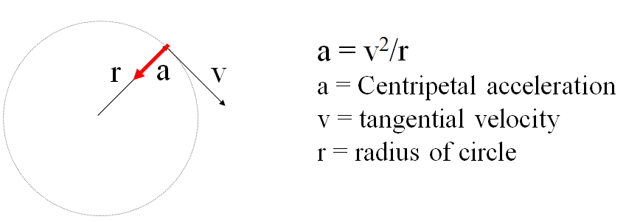

Example - What is the centripetal acceleration of a 1200 kg car going 24 m/s around an 80. m radius corner?

What centripetal force is needed? What is the minimum coefficient of static friction required?

Whiteboards:

|  |  |
| --- | --- |
| 1. What is the centripetal acceleration if a tuna is going 6.2 m/s around a 2.3 m radius corner? (17 m/s/s) | 2. A Volkswagen can do .650 “g”s (6.3765 m/s/s) of lateral acceleration. What is the minimum radius turn at 27.0 m/s? (114 m) |

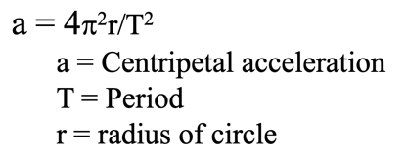Example: A merry-go-round completes a revolution every 7.15 seconds. What is your centripetal acceleration if you are 3.52 m from the center of rotation?

Whiteboard Example

|  |  |
| --- | --- |
| What should be the period of motion if you want 3.5 “g”s (34.335 m/s/s) of centripetal acceleration 5.25 m from the center of rotation? (2.5 s) | RPM Example: What is the acceleration of a point 32 cm out on a grinding wheel spinning at 1200 RPM?  (5035 m/s/s – hint – T = 60 s/1200 Rev) |

**Noteguide for Centripetal Force (Videos 5B) Name**

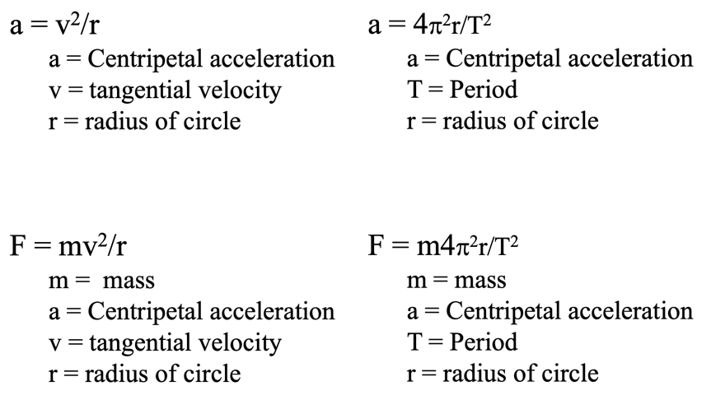

Example: What force is required to swing a 5.0kg object at 6.0m/s in a 75cm radius circle?

Whiteboards:

|  |  |
| --- | --- |
| 1. Ice skates can give 420 N of turning force. What is rmin for a 50. kg skater @10.m/s? (11.9 m) | 2. A ride makes a 60 kg small redheaded child go in a 4.1m radius circle with a force of 470 N. What period? (4.5 s) |
| 3. It takes 35 N of force to make a glob of Jello go in a 2.0 m radius circle with a period of 1.85 seconds What’s the mass? What’s its flavor? (1.5 kg) | |

**Noteguide for "g" force in a Vertical Circle: (Videos 5C1) Name**

Example 0 – A physics teacher twirls a bucket of water in a 1.12 m radius vertical circle. What is the minimum velocity at the top of the circle that will keep the water in the bucket?

Example 1 - A Ferris wheel "pulls" 0.15 "g"s. What "g" force do they feel at the top and bottom?

Example 2 – A rider moving in a 3.75 m radius vertical circle feels 0.80 “g”s inverted at the top of the circle.

A) How many “g”s is the ride pulling?

B) How many “g”s do they feel at the bottom?

Example 3 – On the Rock-O-Plane a rider feels 1.62 "g"s at the bottom of the ride. What is the ride actually pulling, and what "g" force will they feel at the top?

**Noteguide for Vertical Circle: (Videos 5C2) Name**

Example 2 – A 5.00 kg object goes 9.00 m/s in a 3.75 m radius vertical circle. Find the force needed at the top, and at the bottom.

Ex4 – A 1.15 kg mass moves at a uniform speed in a 3.78 m radius circle on the end of a rod. At the top, the rod is exerting a downward force of 5.02 N on the mass.

a) What is the centripetal acceleration of the mass?

b) What is its speed?

c) What force does the rod exert at the bottom?

**Noteguide for Fundamental Forces: (Videos 5D) Name**

|  |  |
| --- | --- |
| Gravity | Weak Nuclear |
| Electro-Magnetic | Strong Nuclear |

Murray goes on a rant about how the short range nature of the Strong Nuclear (Binds neutrons and protons together) limits the number of stable nuclei (they get too big) and influences the number of neutrons.

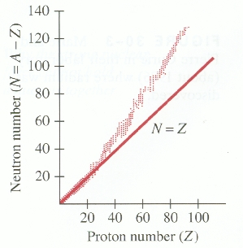

**Noteguide for Universal Gravitation: (Videos 5E) Name**

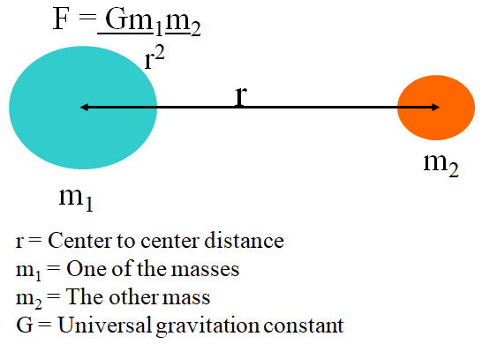

G = 6.67x10-11 Nm2/kg2

Example 1 - Find the force of gravity between a 0.756 kg stapler, and a 0.341 kg marker that is 1.75 m away?

Example 2 - What is the force of gravity between a 1.0 kg mass, and the earth?

(r = 6.38 x 106 m, mearth = 5.97 x 1024 kg)

Whiteboards:

|  |  |
| --- | --- |
| 1. What is the force of gravity between a 5.2 kg shot and a 250. kg wrecking ball whose centers are 2.45 m distant? (1.44 x 10-8 N) | 2. Another shot is 1.45 m from the center of a 250. kg wrecking ball and experiences a force of 1.55 x 10-7 N, what is the mass of the shot? (19.5 kg) |
| 3. What distance from the center of a 512 kg wrecking ball must a 4.5 kg bowling ball be to experience a force of 1.13 x 10-9 N? (11.7 m ) | 4. The moon has a mass of 7.36 x 1022 kg, and a radius of 1.74 x 106 m. What does a 34.2 kg mass weigh on the surface? (55.5 N) |

**Noteguide for Orbit problems (Videos 4F) Name**

Use  or 

G = 6.67 x 10-11 Nm2/kg2

These come from these formulas:

  

Example 1 - What is the velocity of orbit 250 miles above the earth?

r = 6.38x106 m + (250 mi)(1609 m/mi) = 6782250 m, me = 5.97 x 1024 kg

Example 2 - What is the radius of a geosynchronous orbit?

T = 23:56:04 = 23(3600) + 56(60) + 4 = 86164 s, me = 5.97 x 1024 kg

Fill in the Solutions: **(This side is optional)**

|  |  |
| --- | --- |
| **Formula:** | **Calculator:** |
| v = |  |
| mc = |  |
| r = |  |

|  |  |
| --- | --- |
| **Formula:** | **Calculator:** |
| T = |  |
| mc = |  |
| r = |  |

**Noteguide for Kepler's Laws: (Videos 5G) Name**

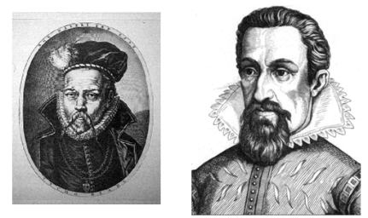

**Johannes Kepler 1571 - 1630**

**Tycho Brahe 1546 - 1601**

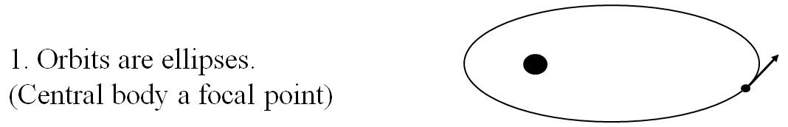

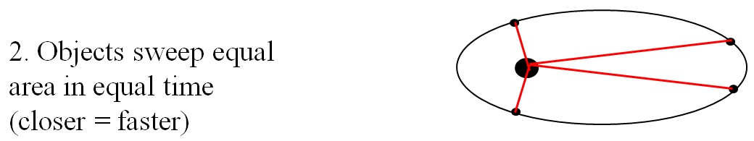

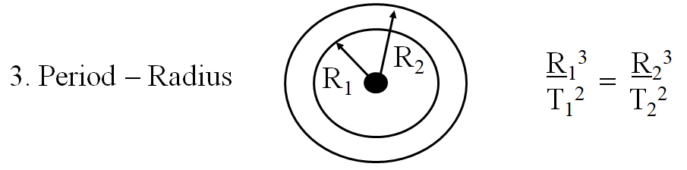

Example 1: What is the radius of a geostationary orbit (T = 1 day)

if for the moon T = 27.4 days, R = 3.8 x 108 m

Example 2: Mars is 1.524 AUs from the sun. If our year is 365.26 days long, how many earth days is Mars's year?

**Noteguide for Banked Corners: (Videos 5H) Name**

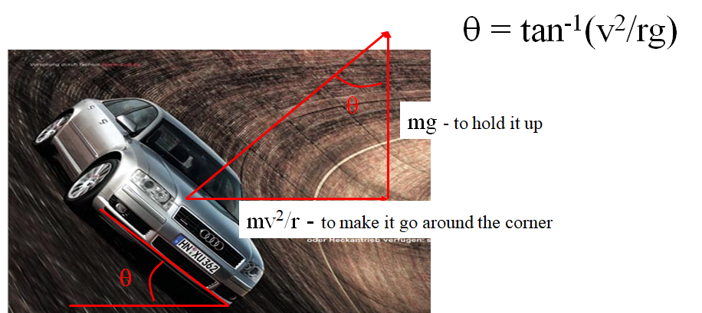

Example: The on ramp from onto I-5 from Nyberg is 40. m in radius maybe. What should be the bank angle to go 27 m/s around it?

Whiteboards:

|  |  |
| --- | --- |
| 1. One of the Terwilliger curves has a radius of 270 m. What is the bank angle for cars to go 29 m/s around it?  (18o) | 2. The on ramp from onto I-5 from Nyberg is 40. m in radius maybe. What should be the bank angle to go 45. m/s (101 mph) around it? (79o)  What about 112. m/s (250 mph) around it? (88o)  What does the angle approach? (90o) |