Noteguide for Universal Gravitation: (Videos 5E) Name
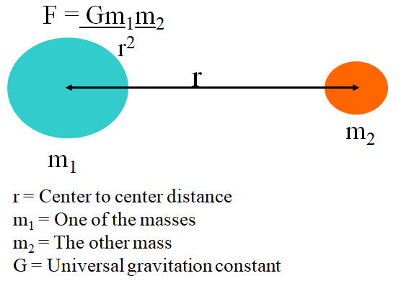
G = 6.67x10⁻¹¹ Nm²/kg²
Example 1 - Find the force of gravity between a 0.756 kg stapler, and a 0.341 kg marker that is 1.75 m away?

Example 2 - What is the force of gravity between a 1.0 kg mass, and the earth?
(r = 6.38 x 10⁶ m, m_{earth} = 5.97 x 10²⁴ kg)

Whiteboards:
1. What is the force of gravity between a 5.2 kg shot and a 250. kg wrecking ball whose centers are 2.45 m distant? (1.44 x 10⁻⁸ N) | 2. Another shot is 1.45 m from the center of a 250. kg wrecking ball and experiences a force of 1.55 x 10⁻⁷ N, what is the mass of the shot? (19.5 kg)
3. What distance from the center of a 512 kg wrecking ball must a 4.5 kg bowling ball be to experience a force of 1.13 x 10⁻⁹ N? (11.7 m ) | 4. The moon has a mass of 7.36 x 10²² kg, and a radius of 1.74 x 10⁶ m. What does a 34.2 kg mass weigh on the surface? (55.5 N)

