Noteguide for Centripetal Force (Videos 5B) Name
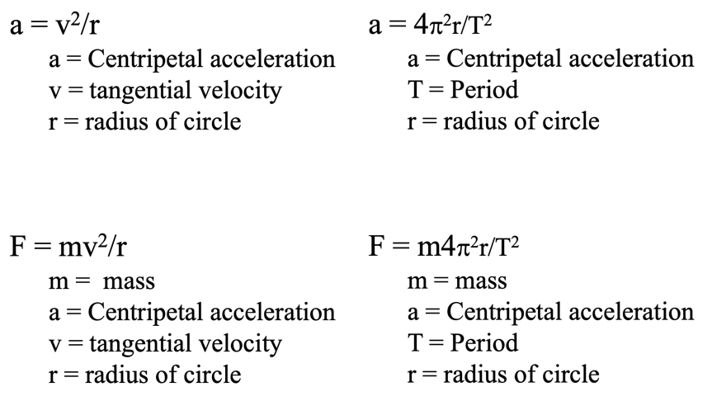
Example: What force is required to swing a 5.0kg object at 6.0m/s in a 75cm radius circle?

Whiteboards:
1. Ice skates can give 420 N of turning force. What is r_{min} for a 50. kg skater @10.m/s? (11.9 m) | 2. A ride makes a 60 kg small redheaded child go in a 4.1m radius circle with a force of 470 N. What period? (4.5 s)
3. It takes 35 N of force to make a glob of Jello go in a 2.0 m radius circle with a period of 1.85 seconds What’s the mass? What’s its flavor? (1.5 kg)

