Noteguide for Centripetal Acceleration (Videos 5A) Name

Velocity = Speed + Direction

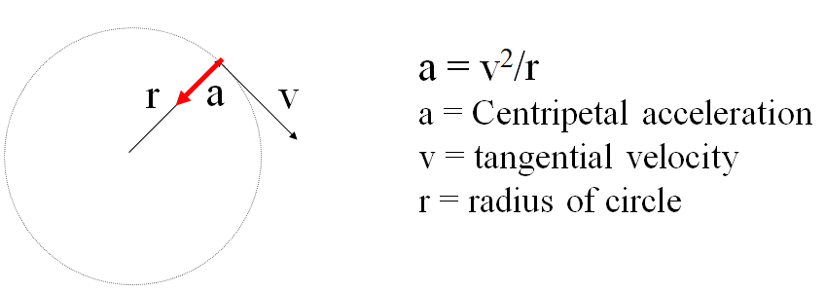

Example - What is the centripetal acceleration of a 1200 kg car going 24 m/s around an 80. m radius corner?

What centripetal force is needed? What is the minimum coefficient of static friction required?

Whiteboards:
1. What is the centripetal acceleration if a tuna is going 6.2 m/s around a 2.3 m radius corner? (17 m/s/s) | 2. A Volkswagen can do .650 “g”s (6.3765 m/s/s) of lateral acceleration. What is the minimum radius turn at 27.0 m/s? (114 m)

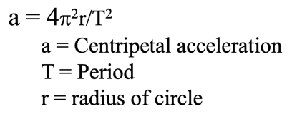
Example: A merry-go-round completes a revolution every 7.15 seconds. What is your centripetal acceleration if you are 3.52 m from the center of rotation?

Whiteboard Example
What should be the period of motion if you want 3.5 “g”s (34.335 m/s/s) of centripetal acceleration 5.25 m from the center of rotation? (2.5 s) | RPM Example: What is the acceleration of a point 32 cm out on a grinding wheel spinning at 1200 RPM?  (5035 m/s/s – hint – T = 60 s/1200 Rev)

