Friction Noteguide Videos 4F Name
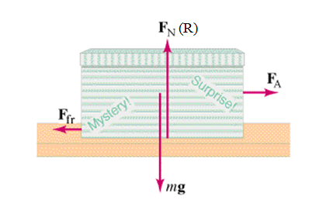
Friction - Force needed to drag one object across another. (At a constant velocity):

Depends on:

Not supposed to depend on:

Table from the book: (IB calls kinetic friction "dynamic")
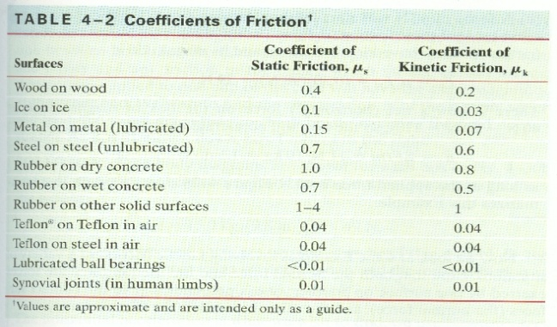

Dynamic Friction - Force needed to keep it going at a constant velocity. (AKA Kinetic friction)
F_{F} = μ_{d}R
Always in opposition to velocity (direction it is sliding)

Static Friction - Force needed to start motion.
F_{F} < μ_{s}R
Keeps the object from moving if it can.
Only relevant when object is stationary.
Always in opposition to applied force.
Calculated value is a maximum

1.

Noteguide for Solving Friction Problems Videos 4G
Sample Problem: A 5.00 kg block rests on a level table where there is a static coefficient of friction of 0.470, and a dynamic of 0.170.
a) What are the dynamic and maximum static forces of friction? (8.3385 N ≈ 8.34 N, 23.0535 N ≈ 23.1 N)

b) If it is at rest and you exert a force of 12.0 N sideways on it what happens? (draw a diagram, understand)

c) If it is at rest and you exert a force of 35.0 N to the right on it, what is the acceleration of the block? (+5.33 m/s/s)

d) If it is sliding to the right and you exert a force of 7.50 N to the left, what is the acceleration of the block? (-3.17 m/s/s)

e) If it is sliding to the right, but decelerating at 0.950 m/s/s, what force is acting on the block? (+3.59 N)

f) It is sliding to the right at 7.20 m/s and it slides to a halt in a distance of 12.0 m. What other force besides friction is exerted on the block as it slides to a halt? (-2.46 N)

