IB Physics
Forces
Chapter 4 Syllabus
Block |  | In Class: | Due on this class: |  | If you miss this class:
1  Nov  2/6 |  | DI-Stupid Teacher Tricks  GW-Force, Net force and weight  DI-More Than One Force | VF 4A, 4B, 4C |  | Watch: Videos 4A, 4B, 4C  Read: 4.1-6
2  Nov  7/8 |  | DI-More Stupid Elevator Tricks  GW-Vertical Acceleration  GW-FA4.2-Vertical Acceleration | VF 4E |  | Watch: Videos 4D, 4E
3  Nov  9/13 |  | SA4.2-Vertical Acceleration (first 30 minutes)  VF-4F Calculating the force of friction  DI-Demos/Solving Friction problems | Turn in FA4.2 |  | Watch: Videos 4F, 4G  Read: 4.7
4  Nov  14/15 |  | GW-Friction problems  GW-FA4.3 - Friction  DI-Forces on inclined planes (last 10 minutes) | (VF 4G?) |  | Watch: Videos 4G, 4H  Read: 4.8
5  Nov  16/19 |  | SA4.3-Friction (First 30 minutes)  IW-Inclined Planes  GW-Inclined Planes | VF 4I  Turn in FA4.3 |  | Watch: Videos 4I
6  Nov  20/21 |  | DI-Force Lab Explained  GW-Inclined Planes  GW-Force Lab
7  Nov  26/27 |  | SA4.4-Inclined Planes (First 30 minutes)  VF-4J Pulleys  GW Pulleys FA4.5 | Turn in FA4.4 |  | Watch: Videos 4J
8  Nov  28/29 |  | GW-Force Lab, Pulleys? | Turn in FA4.5
Nov 30/  Dec 3 |  | Gravity and circular motion!!!!! | Turn In Force Lab  VF 5A, 5B
 | Assignments  - 1 Lab:  - Student designed lab on force (groups of 2) /40 pts  - 4 Formative/ 3 Summative Assessments:  - 4.2 – Vertical Dynamics  - 4.3 – Friction  - 4.4 – Inclined Planes  - 4.5 – Pulleys (no summative) |  |  | Handouts:  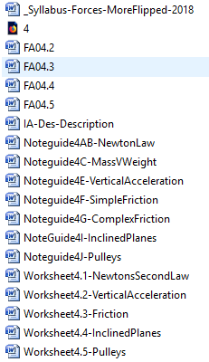 |  |  | *Handouts:  Syllabus-Forces  FA 4.2/FA 4.3/FA 4.4/FA 4.5  Worksheet-NetForceAndFriction  NoteGuide-InclinedPlanesExample  Worksheet-PlanesAndEquil

