4.1 Quizlette - Newton's Second Law (turn this in) Name

F = ma:
1. What net force would accelerate a 2.50 kg mass at a rate of 27.6 m/s/s?

2. What mass accelerates at 6.50 m/s/s when a force of 87.0 N acts on it?

1) 69.0 N, 2) 13.4 kg, 3) 0.385 m/s/s, 4) 589 N, 5) 74.4 kg, 1.62 N/kg

3. What is the acceleration of a 9.10 kg mass if there is a net force of 3.50 N acting on it?

(weight) F_{g} = mg: (Use g = 9.81 N/kg - round to three digits total)
4. What is the weight on earth of a 60.0 kg boy named Brennen?

5. What mass on earth weighs 730. N?

6. A 45.0 kg mass weighs 73.0 N on the moon. What is the "g" (The gravitational field strength) of the moon?

Kinematics then F = ma:
7. What net force would accelerate a 6.80 kg mass from rest a distance of 24.0 m in 5.00 s?

7) 13.1 N, 8) 221 N, 9) 53.3 N, 10) 42.0 m/s, 11) 3.95 s, 12) 35.6 m

8. A 72.0 kg mass accelerates from 5.70 m/s to 18.0 m/s in 4.00 s. What net force acted?

9. A 12.0 kg mass accelerates from 6.20 m/s to 15.0 m/s over a distance of 21.0 m. What net force acted?

F = ma then Kinematics:
10. A 24.0 N net force acts on a 8.00 kg mass. If it accelerates from rest, what is the final velocity in 14.0 s?

11. A net force of 26.0 N acts on a 3.80 kg mass. After what time would the mass reach a speed of 27.0 m/s from rest?

12. A net force of 36.0 N acts on a 8.50 kg mass. What will be its displacement from rest if it accelerates for 4.10 s?

IB Physics
FA 4.1 - Newton's Second Law
Name
Show your work, round to about three total digits, circle your answers, and label them with units. Use the convention that up is positive.
1. What is the acceleration of a 4.39 kg mass if there is an net force of 12.5 N on it? (2.85 m/s/s)

2. What is the mass of an object that weighs 764 N on earth? (77.9 kg)

3. What net force would accelerate a 2.10 kg mass at 7.80 m/s/s? (16.4 N)

4. What net force would accelerate a 0.145 kg baseball from rest to 38.0 m/s in a distance of 0.985 m? (106 N)

5. If there is a net force of 42.0 N on a 3.60 kg mass, what time would it cover 37.0 m from rest? (2.52 s)

IB Physics
FA 4.2 - Vertical
Name
Show your work, round to the correct significant figures, circle your answers, and label them with units. Use the convention that up is positive.
When you have finished this, go to the website and check your answers. If you got a problem wrong, cross it off on the front, and do it correctly on the back.
A 1.60 kg mass hangs on a rope. (Find the force of gravity here)

1. What does the tension need to be in the rope to accelerate the mass upwards at 3.56 m/s/s?

2. What is the acceleration of the mass if the tension in the rope is 19.3 N?

3. What is the tension in the rope if the mass is accelerating downwards at 7.20 m/s/s?

4. If the tension in the rope is 23.5 N, what time will it take the mass to start from rest and move upward 3.40 m?

5. The mass is moving upwards at 5.30 m/s and stops in a distance of 2.80 m. What is the tension in the rope as it is stopping?

Vertical Acceleration Questions from A4.2
Use the convention that up is positive.
+96.1 N  +44.9 N  +10.8 m/s/s  +85.0 N  -35.2 m | 1. A 6.32 kg flour baby hangs on a cord.  a. What is the tension in the cord if the flour baby is accelerating upwards at 5.40 m/s/s?  b. If the flour baby is accelerating downwards at 2.70 m/s/s, what is the tension in the cord?  c. If the tension in the cord is 130. N, what is the acceleration of the flour baby?  d. If the flour baby is moving downwards at 5.50 m/s, and stops in 1.51 s, what was the tension in the cord during this time?  e. There is a tension in the cord of 40.0 N. If the flour baby is initially at rest, what is the displacement of the flour baby 4.50 s later?
+32.5 m/s/s  +19.5 N  +9.82 N  +3.61 N  1.20 s | 2. A 1.30 kg giant gerbil hangs on a cable.  a. If the upward force exerted by the cable is 55.0 N, what is the acceleration of the giant gerbil?  b. What tension in the cable would cause the giant gerbil to accelerate upwards at 5.20 m/s/s?  c. What is the tension in the cable if the giant gerbil has a downward acceleration of 2.26 m/s/s?  d. The giant gerbil accelerates from rest to a downward velocity of 9.56 m/s in a distance of 6.50 m. What was the tension in the cable as it was doing this?  e. There is a tension of 32.0 N in the cable. In what time can the giant gerbil change its velocity from rest to 17.8 m/s upwards?
+29.7 N  +5.57 m/s/s  +84.6 N  +28.4 N  +6.35 m/s | 3. A 5.20 kg baby koala hangs from a rope.  a. What is the tension in the rope if the koala is accelerating downwards at 4.10 m/s/s?  b. If the tension in the rope is 80.0 N, what is the acceleration of the koala?  c. What tension in the rope would effect an upward acceleration of 6.45 m/s/s?  d. From rest, the koala displaces itself downward 7.20 m in 1.82 s. What is the tension in the rope as this is happening?  e. If there is a tension of 58.0 N in the rope, what is the final velocity of the koala when it has risen 15.0 m if the koala started from rest?
-2.08 m/s/s  +8.60 N  +53.9 N  +37.3 m/s  +7.19 N | 4. A 2.20 kg giant cockroach rappels on a very strong string.  a. What is the acceleration of the cockroach if the tension in the string is 17.0 N?  b. If the cockroach is accelerating downwards at 5.90 m/s/s, what is the tension in the string?  c. What tension in the string would cause an upward acceleration of 14.7 m/s/s?  d. If the tension in the string is 38.0 N, and the cockroach is initially at rest, what is the final velocity of the cockroach after 5.00 s?  e. The cockroach is moving upwards at 6.45 m/s and stops in a distance of 3.18 m. What is the tension in the string as he is stopping?
+55.9 N  -3.51 m/s/s  +16.7 N  -11.6 m  +72.4 N | 5. A 4.60 kg gourd hangs on a cord.  a. What is the tension in the cord if the gourd is accelerating upwards at 2.35 m/s/s?  b. What is the acceleration of the gourd if the tension in the cord is 29.0 N?  c. If the gourd is accelerating downwards at 6.19 m/s/s, what is the tension in the cord?  d. If the gourd starts from rest, and the tension in the cord is 28.0 N, what is the displacement of the gourd in 2.50 s?  e. If the gourd accelerates from an upward velocity of 1.12 m/s to 6.57 m/s in a distance of 3.54 m, what is the tension in the cord?

IB Physics
FA 4.3 - Friction
Name
Show your work, round to the correct significant figures, circle your answers, and label them with units. Every force should be labeled "Right" or "Left", and every acceleration should be labeled as "accel" = "acceleration" (speeding up) or "decel" = "deceleration" (slowing down)
When you have finished this, go to the website and check your answers. If you got a problem wrong, cross it off on the front, and do it correctly on the back.
A 4.25 kg block of wood has a kinetic coefficient of friction of 0.120 between it and the level floor.
(Find the static and kinetic friction in this space)

1. If the block is sliding to the right, and I exert a force of 7.80 N to the right, what is the acceleration of the block?

2. If the block is sliding to the left, and I exert a force of 3.50 N to the right, what is the acceleration of the block?

3. If the block is sliding to the right, and accelerating to the right at 2.35 m/s/s, what must be the outside force acting on the block?

4. If the block is sliding to the left, but is decelerating at 3.12 m/s/s, what must be the outside force acting on the block?

5. If the block is initially sliding to the right at 3.50 m/s, and stops in a distance of 1.50 m, what outside force acted on the block as it was stopping?

Friction Questions from A4.3
Use the convention that to the right is positive, and to the left is negative. Every force should be labeled "Right" or "Left", and every acceleration should be labeled as "accel" = "acceleration" (speeding up) or "decel" = "deceleration" (slowing down)
+2.43 m/s/s, decel  -2.70 m/s/s, decel  10.0 N Left  32.6 N Left  39.7 N Right | 1. There is a coefficient of kinetic friction of 0.140 between a 5.20 kg box and the level floor.  a. If the box is sliding to the left, and we exert a force of 5.50 N to the right, what is the acceleration?  b. If the box is sliding to the right, and we exert a force of 6.90 N to the left, what is the acceleration?  c. The box is sliding to the right, but is decelerating at 3.30 m/s/s, what outside force besides friction is acting on it?  d. If the box is sliding and accelerating to the left at 4.90 m/s/s, what force must be acting on it?  e. The box slides from rest to the right reaching a velocity of 14.5 m/s in a distance of 16.8 m. What outside force was acting?
+0.696 m/s/s, accel  +0.462 m/s/s, decel  25.3 N Right  28.8 N Right  +6.75 m/s | 2. There is a coefficient of kinetic friction of 0.105 between a 4.75 kg block of wood and the level floor.  a. If there is a force of 8.20 N to the right, and the block is sliding to the right, what is the acceleration?  b. If the block is sliding to the left, and there is a force of 2.70 N to the left, what is the acceleration of the block?  c. What applied force would make the block accelerate and slide to the right at 4.30 m/s/s?  d. If the block is sliding to the left, but is decelerating at 7.10 m/s/s, what force must be applied to it?  e. If you apply 8.90 N to the right and the block starts to slide to the right from rest, what will be the velocity in 8.00 seconds?
-1.48 m/s/s, decel  -4.53 m/s/s, decel  2.01 N Left  36.1 N Left  72.4 N Right | 3. There is a coefficient of kinetic friction of 0.310 between an 8.35 kg block of wood and the level floor.  a. If the block is sliding to the right, and there is a force of 13.0 N to the right, what is the acceleration?  b. If the block is sliding to the right, but there is a force of 12.4 N to the left, what is the acceleration?  c. If the block is sliding to the left, but is decelerating at 2.80 m/s/s, what outside force must be acting?  d. If the block is sliding to the right, but is decelerating at 7.36 m/s/s, what is the force acting on the block?  e. From rest the block reaches a speed of 15.0 m/s to the right from rest in a distance of 20.0 m. What force was acting?
-2.87 m/s/s, decel  -0.518 m/s/s, accel  +18.5 N Right  10.1 N Left  13.7 N Left | 4. There is a coefficient of kinetic friction of 0.155 between a 3.10 kg block of wood and the level floor.  a. If the block is sliding to the right, and you exert a force of 4.19 N to the left, what is the acceleration?  b. If the block is sliding to the left, and you exert a force of 6.32 N to the left, what is the acceleration?  c. If the block is sliding and accelerating to the right at 4.45 m/s/s, what force must be applied?  d. If the block is sliding to the left and accelerating to the left at 1.75 m/s/s, what force must be applied?  e. The block displaces itself to the left 12.0 m from rest in 2.87 s. What force must have acted?
+0.780 m/s/s, decel  +1.62 m/s/s, accel  37.1 N Left  8.99 N Left  +10.9 m/s | 5. There is a coefficient of kinetic friction of 0.235 between an 8.85 kg box and the level floor.  a. If the box is sliding to the left, and there is a force of 13.5 N to the left, what is the acceleration?  b. If the box is accelerating to the right, and there is a force of 34.7 N to the right, what is the acceleration?  c. If the box is sliding to the right, but is decelerating at 6.50 m/s/s, what force must be acting on the box?  d. If the box is sliding to the left, but is decelerating at 1.29 m/s/s, what must be the force acting on the box?  e. If the box is sliding to the right, and there is a force of 32.0 N to the right, what will be its final velocity from rest when is has gone 45.0 m?

IB Physics
FA 4.4 - Inclined Planes
Name
Show your work, round to the correct significant figures, circle your answers, and label them with units. Label your forces either "Up the plane" or "Down the plane" explicitly. In addition, label every acceleration as "accel" = "acceleration" (speeding up) or "decel" = "deceleration" (slowing down)
When you have finished this, go to the website and check your answers. If you got a problem wrong, cross it off on the front, and do it correctly on the back.
A 5.20 kg block of wood is on a 30.0º inclined plane where the static coefficient of friction is 0.650, and the kinetic is 0.120.

F_{parallel} = 25.506 N
F_{kinetic} = 5.301 N
F_{static} = 28.715 N
1. Will the block stay on the plane if it is initially at rest? Back up your answer with numbers. What is the acceleration of the block if it is sliding freely down the plane?

2. If the block is sliding up the plane, and there is a force of 14.0 N down the plane, what is the acceleration of the block?

3. If the block is sliding down the plane, and there is a force of 7.50 N up the plane, what is the acceleration of the block?

4. If the block is sliding up the plane, but decelerating at 5.34 m/s/s, what outside force must be acting on the block?

5. If the block is sliding down the plane, and accelerating at 2.28 m/s/s down the plane, what force is acting on the block?

Inclined Planes Questions from A4.4
Show your work, round to the correct significant figures, circle your answers, and label them with units. The signs use the convention that up the plane is positive, and down, negative. Label your forces either "Up the plane" or "Down the plane" explicitly. Label every acceleration as either "accel" = "acceleration" (speeding up) or "decel" = "deceleration" (slowing down)
No - F|| of 23.6 N is much bigger than FFs of 9.95 N  -2.31 m/s/s (accel)  +6.80 m/s/s (accel)  +2.41 N Up the plane  +25.3 N Up the plane | 1. A 3.10 kg block of wood is on a 51.0º inclined plane where the static coefficient of friction is 0.520, and the kinetic is 0.380  a. Will the block stay on the plane if it is initially at rest? Back up your answer with numbers.  b. What is the acceleration of the block if it is sliding down the plane and there is a force of 9.20 N up the plane?  c. What is the acceleration of the block if it is sliding up the plane and there is a force of 52.0 N up the plane?  d. What applied force would cause the block to slide down the plane with an acceleration of 4.50 m/s/s down the plane?  e. What applied force would cause the block to slide up the plane with a deceleration of 1.80 m/s/s?
-3.54 m/s/s (accel)  -7.96 m/s/s (accel)  -7.37 m/s/s (decel)  +9.99 N Up the plane  +13.0 N Up the plane | 2. A 1.40 kg block of wood is on a 27.0º inclined plane where the static coefficient of friction is 0.220, and the kinetic is 0.105  a. What is the acceleration of the block if it is sliding freely down the plane?  b. What is the acceleration of the block if it is sliding down the plane and there is a force of 6.20 N down the plane?  c. What is the acceleration of the block if it is sliding up the plane and there is a force of 2.80 N down the plane?  d. What applied force would cause the block to slide down the plane with an deceleration of 3.60 m/s/s?  e. What applied force would cause the block to slide up the plane with an acceleration of 3.90 m/s/s up the plane?
-4.53 m/s/s ( accel)  +4.19 m/s/s (accel)  -0.935 m/s/s (accel)  -26.9 N Down the plane  +7.58 N Up the plane | 3. A 4.50 kg block of wood is on a 39.0º inclined plane where the static coefficient of friction is 0.365, and the kinetic is 0.215  a. What is the acceleration of the block if it is sliding freely down the plane?  b. What is the acceleration of the block is it is sliding up the plane and there is a force of 54.0 N up the plane?  c. What is the acceleration of the block if it is sliding down the plane, and there is a force of 16.2 N acting up the plane?  d. What applied force would make the block slide up the plane, but decelerate at 13.8 m/s/s?  e. What applied force would make the block slide down the plane with an acceleration of 2.85 m/s/s down the plane?
-1.63 m/s/s (accel)  -3.96 m/s/s (accel)  +0.612 m/s/s (accel)  +290. N Up the plane  -93.9 N Down the plane | 4. A 24.0 kg block of wood is on a 22.0º inclined plane where the static coefficient of friction is 0.385, and the kinetic is 0.225  a. What is the acceleration of the block if it is sliding freely down the plane?  b. What is the acceleration of the block if it is sliding down the plane and there is a force of 56.0 N down the plane?  c. What is the acceleration of the block if it is sliding up the plane and there is a force of 152 N up the plane?  d. What applied force would cause the block to slide up the plane with an acceleration of 6.37 m/s/s up the plane?  e. What applied force would cause the block to slide down the plane with an acceleration of 5.54 m/s/s down the plane?
Yes - the FFs of 93.9 N is slightly bigger than the F|| of 93.4 N  -17.1 m/s/s (decel)  -13.6 m/s/s (accel)  +244 N Up the plane  +88.7 N Up the plane | 5. A 16.2 kg block of wood is on a 36.0º inclined plane where the static coefficient of friction is 0.730, and the kinetic is 0.415  a. Will the block stay on the plane if it is initially at rest? Back up your answer with numbers.  b. What is the acceleration if the block is sliding up the plane, and there is a force of 130. N down the plane?  c. What is the acceleration of the block if it is sliding down the plane, and there is a force of 180. N down the plane?  d. What applied force is needed to make the block slide up the plane and accelerate up the plane at 6.00 m/s/s?  e. What applied force is necessary to make the block slide down the plane, but decelerate at 3.00 m/s/s?

IB Physics
FA 4.5 - Pulleys
Name
Show your work, round to the correct significant figures, circle your answers, and label them with units.
1. Consider the following situation where the hanging mass moves downward, and there is a coefficient of dynamic friction of 0.152 between the surface and the block resting on it. Neglect the string and pulley friction and mass.
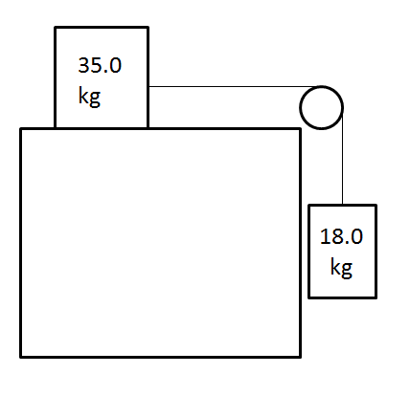
Find the tension in the string and the acceleration of the system if the 35 kg block is initially sliding to the right.
(2.35 m/s/s right/down, 134 N)

2. The 24.0 degree inclined plane is frictionless, neglect the mass of the pulley and the string:
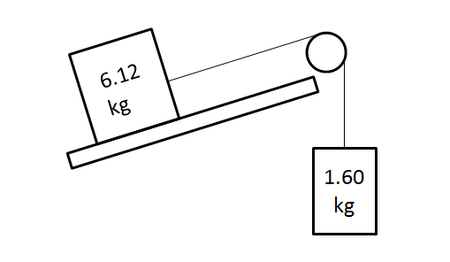
Find the tension in the string and the acceleration of the system. (1.13 m/s/s down the plane/up, 17.5 N)

Pulleys
Directions: Show the solutions (i.e. your work) to these on a separate sheet of paper.
a) 44.4 N, 1.92 m/s/s  b) 9.81 N, 0.00382 m/s²  c) 9.79 N, 9.79 m/s/s  d) 16.6 kg  e) 47.8 N, 1.32 m/s/s | B  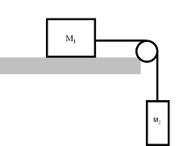  A | 5. The plane and pulley are frictionless  for a) – d). e) has a bit o’ friction  a) If A has a mass of 23.1 kg, and B has a mass of 5.63 kg, what is the tension in the string, and the acceleration of the system?  b) If A has a mass of 2567 kg, and B has a mass of 1.00 kg, what is the tension in the string, and the acceleration of the system?  c) If A has a mass of 1.00 kg, and B has a mass of 500. kg, what is the tension in the string, and the acceleration of the system?  d) If A has a mass of 35.0 kg, What does B need to be so that the system has an acceleration of 3.15 m/s/s?  e) Answer part a) with a coefficient of friction of 0.0759 between block A and the plane.
a) 2.8 m/s/s, 35 N  b) -0.48 m/s/s, 18 N  c) 3.55 kg  d) 7.5 kg |  | 6. The plane and pulley are frictionless.  a) If A and B both have a mass of 5.0 kg, and the plane makes an angle of 25º with the horizontal, what is the acceleration and the tension in the cable?  b) Solve as in problem a), but give A a mass of 5.0 kg, and B a mass of 1.78 kg.  c) Suppose A has a mass of 4.51 kg, and accelerates from rest 3.27 m up the ramp in 1.81 seconds. What must the mass of B be? (use 25.0º)  d) If the plane angle is 30º and A is 15 kg, what should the mass of B be to prevent acceleration?

a) 6.43 m/s/s 14.6 N  b) .468 kg  c) 27.2 N |  | 7. The plane and pulley are frictionless, and the plane makes an angle of 21.0º with horizontal.  a) If A has a mass of 5.00 kg, and B 4.30 kg, what are the acceleration and the tension in the cable?  b) If A has a mass of 3.12 kg, and the tension in the cable is 2.56 N, what must the mass of B be?  c) Using the masses from part a), suppose you observed an acceleration of only 3.50 m/s/s. What frictional force must exist between A and the plane? (assume the plane is not frictionless)

Translational Equilibrium 9.1
1. | Find the third force (the equilibrant) that would prevent the system from accelerating. 23.16 N At 292.8º Trig angle. (22.8º to the right of the -y axis)
2. | Find the third force (the equilibrant) that would prevent the system from accelerating. 6.000 N At 348.9º Trig angle. (11.1º below the +x axis)
3.  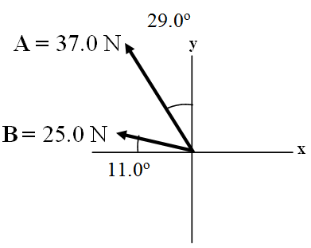 | Find the third force (the equilibrant) that would prevent the system from accelerating. 56.4 N @ 318.8º Trig angle. (41.2º below the +x axis)
4. | Cable A makes an angle of 63.0º with the horizontal, and B makes an angle of 23.0º with the horizontal. What is the tension in each cable for there to be no acceleration of the system?  A = 606 N  B = 299 N
5. 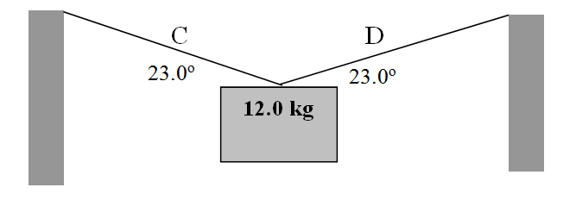 | Find the tensions in Cable C and D:  C = 151 N  D = 151 N

6.  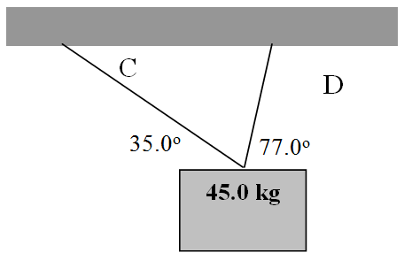 | Find the tensions in Cable C and D:  C = 107 N  D = 390. N
7.  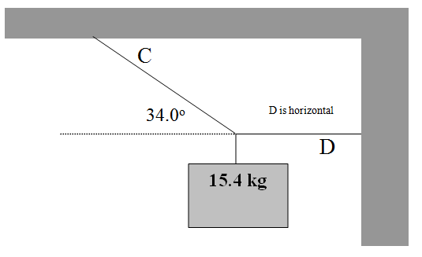 | Find the tensions in Cable C and D:  C = 270. N  D = 224 N
8.  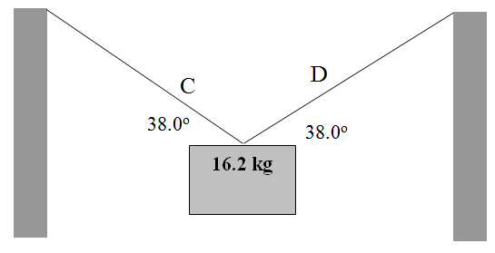 | Find the tensions in Cable C and D:  C = 129 N  D = 129 N
9.  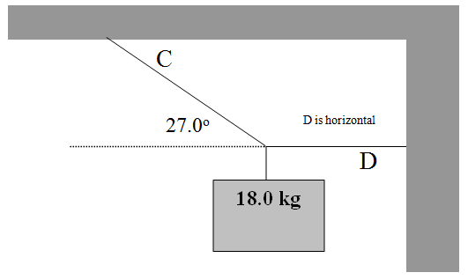 | Find the tensions in Cable C and D:  C = 389 N  D = 347 N
10. | Cable A has a force of 23 N along it, what must be the tensions in cable C and B for there to be no acceleration of the system?  B = 17 N  C = 27 N

IB Physics
FA9.1 - Translational Equilibrium
Name

Favorite Book
Show your equations of equilibrium, and circle your answers and use sig figs to receive full credit.
1. Find the Equilibrant (The third force that would cause translational equilibrium) – express it as an angle magnitude vector. Draw it with its tail on the origin, and label its magnitude, and an angle with one of the axes. Write your answer with 3 sig figs, but carry at least 4 so you don’t make rounding errors.
A = 17.0 N
B = 23.0 N
42.0º
31.0º
x
y
Draw your picture here:

X:

Y:

2. Find the tensions in the cables C and D. Set up your x and y equations where indicated and solve.
35.0 kg
56.0º
34.0º
C
D

X:

Y:

