Noteguide for Inclined Planes Videos 4I Name

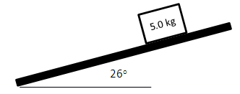
A 5.0 kg object is on an inclined plane that makes an angle of 26º with the horizontal. Make up the plane positive. The coefficient of kinetic friction is 0.35, and static is 0.52
A) What are the components of gravity parallel and perpendicular to the plane? What is the force of kinetic friction, and what is the maximum static friction? Would the block be able to remain at rest on the plane?

B) Were the block to slide down the plane, what would be its acceleration?

C) What force would make the block slide up the plane with an acceleration of 2.4 m/s/s?

D) What force in what direction would make the block slide down the plane with an acceleration of 0.80 m/s/s?

E) Suppose there is an outside force of 9.5 N acting up the plane, what force in what direction would make the block slide down the plane with an acceleration of 1.9 m/s/s down the plane?

