Noteguide for Vertical Acceleration - Videos 4E Name

Example 1

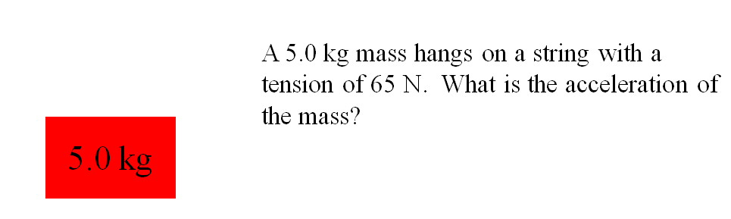

Example 2

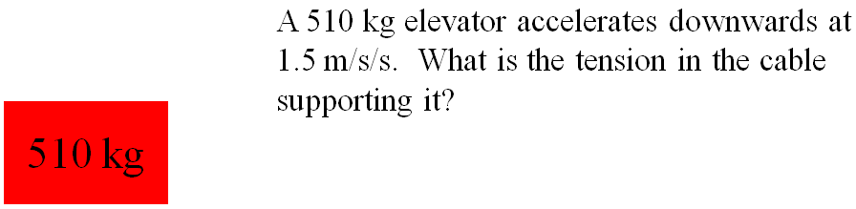

Example 3

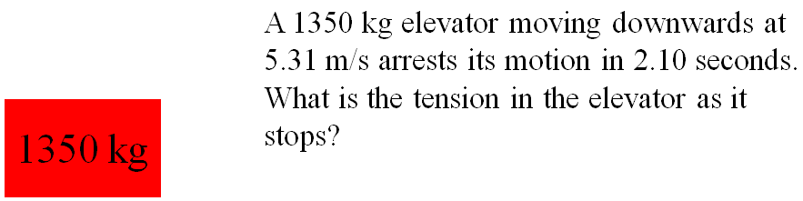

(Do the whiteboards on the back)

Try to do these without looking at the video, but if you get stuck, watch the video until you get unstuck, and do it from there.
1. A 314 kg elevator accelerates upward 4.7 m/s/s. What is the tension in the cable supporting it?  (4556 ≈ 4600 N) | 2. A 314 kg elevator accelerates downward at 2.7 m/s/s. What is the tension in the cable supporting it? (2233 ≈ 2200 N)
3. A 10.0 kg mass hangs on a string with a tension of 126 N, what is its acceleration?  (2.79 ≈ 2.8 m/s/s upwards) | 4. A 10.0 kg mass hangs on a string with a tension of 52.0 N, what is its acceleration?  (-4.61 ≈ 4.6 m/s/s downwards)
5. A 62 kg climber falling at 9.4 m/s has their downward motion arrested in a distance of 5.3 m. What is the tension on the rope if the acceleration is uniform? (1125 ≈ 1100 N) | 6. A 1420 kg elevator is moving upwards at 4.1 m/s and stops in 1.7 s. What is the tension in the cable supporting the elevator as it stops?  (10,505 ≈ 11,000 N)

