Noteguide for Net Force - Videos 4D Name

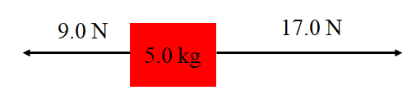
Steps:

1.

2.

3.

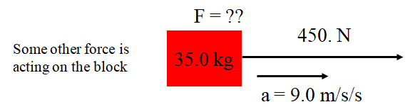

Try these example problems. If you don't get the answer, watch the video to see how.
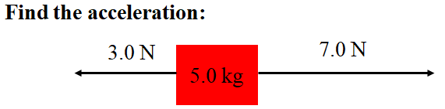(0.80 m/s/s) | 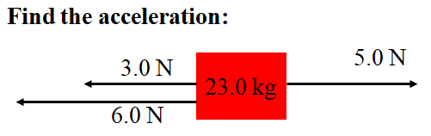(-0.17 m/s/s)
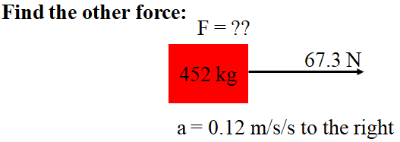(-13 N) | 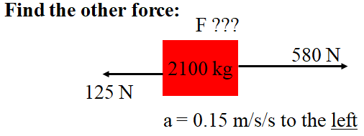(-770 N)

