IB Physics
FA 4.5 - Pulleys
Name
Show your work, round to the correct significant figures, circle your answers, and label them with units.
1. Consider the following situation where the hanging mass moves downward, and there is a coefficient of dynamic friction of 0.152 between the surface and the block resting on it. Neglect the string and pulley friction and mass.
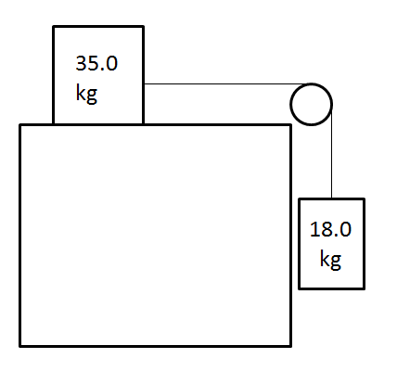
Find the tension in the string and the acceleration of the system if the 35 kg block is initially sliding to the right.
(2.35 m/s/s right/down, 134 N)

2. The 24.0 degree inclined plane is frictionless, neglect the mass of the pulley and the string:
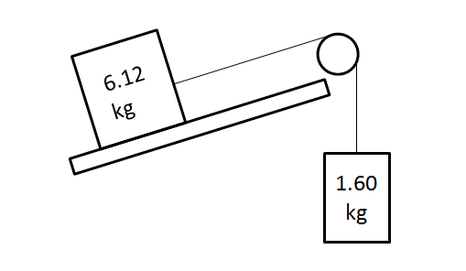
Find the tension in the string and the acceleration of the system. (1.13 m/s/s down the plane/up, 17.5 N)

