3.1 Vector Quizlette (turn this in) Name

B. Find these Vector Components and write each vector as a proper component vector:
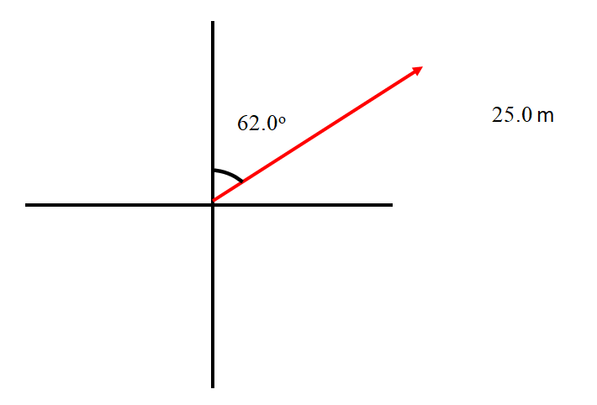
#1: 22.1 m x + 11.7 m y #2: -72.4 m, x + -38.5 m y #3: -44.0 m x + 9.36 m y
#1

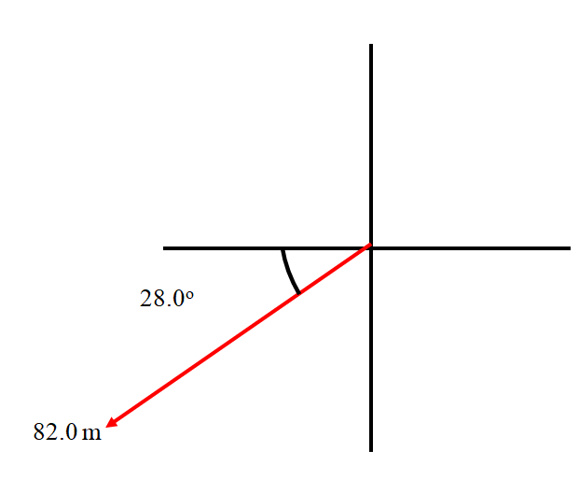
#2

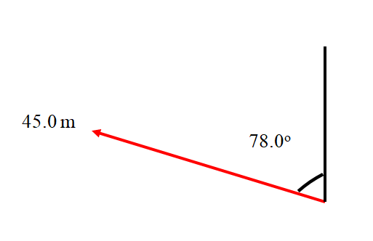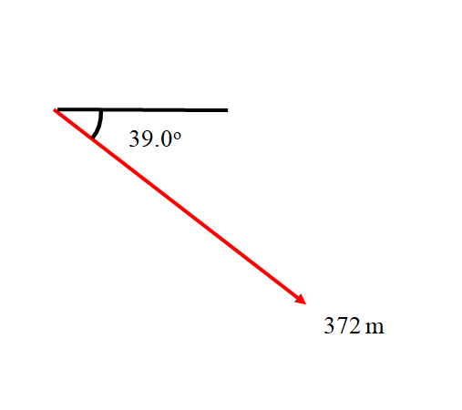
#3
#4: 289 m x + -234 m y #5: -16.3 m x + 14.7 m y #6: -179 m x + -167 m y
#4

#5

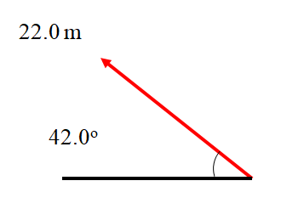

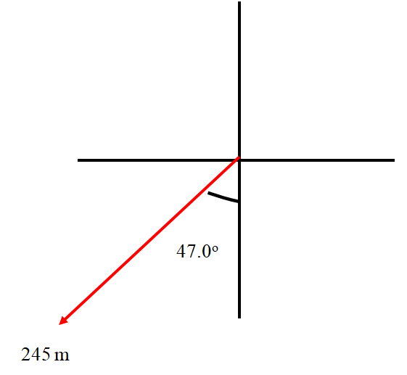
#6

C. Add these component vectors:
A: 12 m x + 34 m y  B: 16 m x + 9.0 m y  A+ B:  #a  28 m x + 43 m y | A: 1.20 m x + 3.10 m y  B: -5.30 m x + 1.30 m y  A+ B:  #b  -4.1 m x + 4.4 m y
A: 3.60 m x + -5.60 m y  B: 12.5 m x + 8.10 m y  A+ B:  #c  16.1 m x + 2.50 m y | A: 12.6 m x + 58.1 m y  B: 16.5 m x + -96.0 m y  A+ B:  #d  29.1 m x + -37.9 m y

D. Draw these vectors as Angle Magnitude vectors. The vector should be an arrow, and calculate and label its magnitude (hypotenuse) and the angle:
1) 10.0 m right and up 53.1º above the x axis, 2) 7.82 m left and up at 54.9º above the x axis
3) 6.44 m left and down 37.3º below the x axis, 4) 67.4 m right and down 33.3º below the x axis

1) 6.00 m x + 8.00 m y

2) -4.50 m x + 6.40 m y

3) -5.12 m x + -3.90 m y

4) 56.3 m x + -37.0 m y
E1: Adding two Angle Magnitude Vectors (Just like the test…)

Find the Components of these two vectors:
Carry three decimal places in your calculations.

Mag. = 12.0 m, θ = 21.0º

1 = x + y

2 = x + y

Mag. = 8.00 m, θ = 17.0º

Add the Two Vectors: 1+2 = x + y

Draw a picture of the resultant vector with its tail on the origin, find its magnitude, and label an angle indicating its direction:

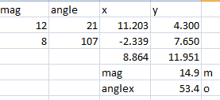 14.9 m, up and right, above 53.4º the x-axis
E2: Adding two Angle Magnitude Vectors

Find the Components of these two vectors:
Carry three decimal places in your calculations.

1 = x + y
Mag. = 18.0 m, θ = 43.0º

2 = x + y

Mag. = 42.0 m, θ = 12º

Add the Two Vectors: 1+2 = x + y

Draw a picture of the resultant vector with its tail on the origin, find its magnitude, and label an angle indicating its direction:

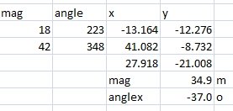 34.9 m, right and down at 37º below the x axis

IB Physics
FA 3.1 – Vectors
Name
Carry a couple of extra sig figs, round only the final magnitude and angle to the correct number of sig figs.
When you have finished this, go to the website and check your answers. If you got a problem wrong, cross it off on the front, and do it correctly on the back.
Find the Components of these two vectors:

Mag. = 13.4 m, θ = 42.0º
1 = x + y

2 = x + y

Mag. = 6.12 m, θ = 11.3º

Add the Two Vectors: 1+2 = x + y

Draw a picture of the resultant vector with its tail on the origin, find its magnitude, and label an angle indicating its direction:

Physics
Vector Sheet
Directions: make no marks on this sheet. Do these problems on your own paper and check your answer. The answers are on the left side.
Part 1 - Convert these Angle-Magnitude vectors to Vector-Component vectors.
1) 13 m/sx + 7.3m/sy  2) 230mx + 190my  3) 18.6m/sx -26.6m/sy  4) -73.8m/sx - 94.6 m/sy  5) -126mx + 40.8my  6) -140m/s/sx - 80.m/s/sy | 5) 132 m  18.0º  40º  2) 300. m  30.º  6) 160 m/s/s  38º  4) 120.0 m/s m/s  29º  1) 15 m/s  35º  3) 32.5 m/s

Part 2 - Convert these Vector-Component vectors into Angle-Magnitude vectors. Find the angle they make with the x axis
7) 7.8 m, up and right 50.o above the x axis  8) 7.62 m, left and up 66.8o above the x axis | 7. 5.0 mx + 6.0 my | 8. -3.00 mx + 7.00 my
9) 5.3 m, left and down 37.3o below the x axis  10) 5.81 m, right and down 78.9o below the x axis | 9. -4.2 mx -3.2 my | 10. 1.12 mx - 5.70 my

Part 3 - Add or Subtract these Vector component vectors from Part 2
11) 2.0mx + 13.0my  12) 8.0mx - 1.0my | 11. #7 + #8 | 12. #7 - #8
13) -1.2mx - 10.2my  14) -3.1mx - 8.9my | 13. #9 - #8 | 14. #10 + #9

Part 4 - Add these Angle-Magnitude vectors analytically, and express their sum as an Angle-Magnitude Vector.
15. (Answer: 18m, right and a little down, 7.7o below the x-axis) | 16. (Answer: 44m, right and down, 31o below the x-axis)

Cliff Problem Quizlette Name

Red Elk runs at a speed of 9.20 m/s horizontally off a cliff that is 6.40 m above the water.

A) Set up your horizontal/vertical table, fill it with known quantities, and solve for everything you don’t know. (You know horizontally: both velocities and the acceleration, and vertically: the displacement, the initial velocity, and the acceleration)

B) What time is he in the air?  (1.14 s) | C) What is his final vertical velocity of impact? (-11.2 m/s) | D) How far from the base of the cliff does he hit the water?  (10.5 m)
E) Draw a picture of his velocity of impact, and turn it into an angle-magnitude velocity vector. Find the angle with the horizontal, and label both the angle and the magnitude. (14.5 m/s, 50.6º below horiz) |  | F) What is his speed of impact with the water? (14.5 m/s)

Red Elk runs at a speed of 9.20 m/s horizontally off a cliff that is 6.40 m above the water.
When Red Elk is 3.1 m above the water, inspiration strikes him. (set up another H|V table and solve)
- What is Red Elk’s position (relative to the cliff edge) when he is 3.10 m above the water? (how far over, how far down from the edge) (7.55 m over, -3.30 m down)
- What is Red Elk’s velocity in Vector Components and Angle Magnitude (draw a picture) notation when he is 3.1 m above the water? (9.20 m/s x + -8.05 m/s y, 12.2 m/s 41.2º below horiz)

What is Red Elk’s position (VC notation relative to the cliff edge) and Velocity (VC and AM - draw a picture) at 0.50 seconds after leaving the edge of the cliff?
(4.60 m over, -1.23 (down), 9.20 m/s x + -4.905 m/s y, 10.4 m/s 28.1º below horiz)

What is Red Elk’s position (VC notation relative to the cliff edge) and Velocity (VC and AM - draw a picture) when he has covered 8.0 horizontal meters of distance?
(8.00 m over, -3.71 m down, 9.20 m/s x + -8.53 m/s y, 12.5 m/s 42.8º below horiz)

IB Physics
FA 3.2 - Cliff Problems
Name
Show your work, circle your answers, and use significant digits to receive full credit (but don't round until the end) Ignore air friction, use the convention that down is negative, and use g = 9.81 m/s/s.
When you have finished this, go to the website and check your answers. If you got a problem wrong, cross it off on the front, and do it correctly on the back.
1-3: A ball rolls off the edge of a 15.0 m tall cliff with a purely horizontal velocity, and strikes the ground at a distance of 12.4 m from the base of the cliff.
1. What time was the ball in the air?

2. What was the ball’s horizontal velocity?

3. What is the speed of impact?

4-5: a) When the ball has covered a horizontal distance of 5.00 m:
4. What is the position of the ball? (How far out, how far down)

5. What is the velocity of the ball in vector components and as an angle and a magnitude?
Draw a picture of the velocity vector.

Cliff Practice Problems for A3.2
Round to the correct significant figures, Ignore air friction and use the convention that down is negative. g = 9.81 m/s/s
1.22 s  5.59 m/s  13.2 m/s  2.52 m x + -0.993 m y  5.59 m/s x + -4.41 m/s y  7.13 m/s 38.3º blw. hrz. | 1. A fifth grader is projected with a purely horizontal velocity from an 7.25 m tall cliff and lands 6.80 m from the base of the cliff.  What time is the child in the air?  With what purely horizontal velocity was he projected from the top of the cliff?  What is the speed of impact?  At 0.450 seconds after he leaves the edge of the cliff:  What is the position of the child? (How far out, how far down)  What is the velocity of the child in vector components and as an angle and a magnitude?  Draw a picture of the velocity vector.
81.7 m  86.9 m  45.3 m/s  60.0 m x + -38.9 m y  21.3 m/s x + -27.6 m/s y  34.9m/s, 52.4º blw. hrz. | 2. A Chevy drives off the edge of a cliff. The instant it leaves the edge, it has a purely horizontal velocity of 21.3 m/s, and it strikes the ground after 4.08 seconds.  How high is the cliff?  How far from the base of the cliff does the car land?  What is the speed of impact?  When the car has gone horizontally 60.0 m:  What is the position of the car? (How far out, how far down)  What is the velocity of the car in vector components and as an angle and a magnitude?  Draw a picture of the velocity vector.
1.30 m  0.514 s  5.22 m/s  0.545 m x + -0.800 m y  1.35 m/s x + -3.96 m/s y  4.19 m/s, 71.2º blw. hrz. | 3. A meatball leaves the edge of a table with a purely horizontal velocity of 1.35 m/s, and lands 0.694 m from the base of the table.  How high is the table?  What time does it take the meatball to hit the ground?  What is the speed of impact?  When the meatball has gone down 0.800 m:  What is the position of the meatball? (How far out, how far down)  What is the velocity of the meatball in vector components and as an angle and a magnitude?  Draw a picture of the velocity vector.
0.887 s  2.43 m  9.12 m/s  1.12 m x + -0.825 m y  2.74 m/s x + -4.02 m y  4.87 m/s, 55.7º blw. hrz. | 4. A Giant Lizard is projected sideways at 2.74 m/s from the top of a 3.86 m tall cliff.  What time is the lizard in the air?  How far from the base of the cliff does the lizard land?  What is the speed of impact?  At 0.410 seconds after it leaves the edge of the cliff:  What is the position of the lizard? (How far out, how far down)  What is the velocity of the lizard in vector components and as an angle and a magnitude?  Draw a picture of the velocity vector.
6.71 m  7.06 m/s  13.5 m/s  4.00 m x + -1.57 m y  7.06 m/s x + -5.56 m/s y  8.99 m/s, 38.2º blw. hrz. | 5. A can of Spotted Dick rolls off the edge of a cliff with a purely horizontal velocity, and strikes the ground 1.17 s later at a distance of 8.26 m from the base of the cliff.  How high is the cliff?  What was the can's horizontal velocity?  What is the speed of impact?  When the can has covered a horizontal distance of 4.00 m:  What is the position of the can? (How far out, how far down)  What is the velocity of the can in vector components and as an angle and a magnitude?  Draw a picture of the velocity vector.

Arc Problem Quizlette Name

Red Elk shoots an air rocket at an angle of 57.0º above the horizontal at a speed of 25.0 m/s on a very level field.

A) Break the velocity vector into components. (These become your initial velocities for x and y) Set up your horizontal/vertical table, fill it with known quantities, and solve for everything you don’t know. (You know horizontally: both velocities and the acceleration, and vertically: the displacement, both velocities, and the acceleration) (13.616 m/s x + 20.967 m/s y)

B) What are the initial horizontal and vertical velocity components? (13.616 m/s x + 20.967 m/s y) | C) What time is the rocket in the air? (4.27 s) | D) How far does the rocket go before hitting the ground? (58.2 m)
E) What is the greatest height the rocket reaches? (22.4 m) |  | F) What is the speed of the rocket at the highest point?  (13.6 m/s)

Red Elk shoots an air rocket at an angle of 57.0º above the horizontal at a speed of 25.0 m/s on a very level field.
What is the position (in VC notation, how far over, how far up) and velocity (AM notation - draw a picture) at 1.50 seconds? (20.4 m over and 20.4 m up, 15.0 m/s, 24.7º above horizontal)

Suppose the rocket hits a very tall wall that is 45 m away. How high up on the wall does it hit, and what is the velocity of impact in AM notation? (draw a picture) (15.7 m up the wall, 17.8 m/s 40.1º below the horizontal)

IB Physics
FA 3.3 - Arc Problems
Name
Show your work, circle your answers, and use significant digits to receive full credit (but don't round until the end) Ignore air friction, use the convention that down is negative, and use g = 9.81 m/s/s.
When you have finished this, go to the website and check your answers. If you got a problem wrong, cross it off on the front, and do it correctly on the back.
1-3: A ball is launched at 27.2 m/s at an angle of 75.0º above horizontal on a level field.
1. What time is the ball in the air?

2. What horizontal distance does it travel before hitting the ground again?

3. At 3.20 s after launch, what are the position of the ball and the velocity of the ball in vector components? Write them both as proper component vectors.

4-5: A ball is launched at 31.7 m/s at an angle of 56.0º above horizontal from the top of a 65.3 m tall cliff. (it lands 65.3 m lower in elevation)
4. What is its speed of impact?
What time does it take to hit the ground?

5.What horizontal distance does it travel before hitting the ground again?

Arc Practice Problems for A3.3
Round to the correct significant figures, Ignore air friction and use the convention that down is negative. g = 9.81 m/s/s
6.53 s  36.8 m  6.11 m/s, 22.4º blw hrz | 1. A big %$# ham is launched at 32.5 m/s at an angle of 80.0º above horizontal on a level field.  a. What time is the ham in the air?  b. What horizontal distance does it travel before hitting the ground again?  c. What is its velocity as an angle and a magnitude exactly 3.50 s after it is launched? (Draw a picture of the velocity vector)
10.5 s  805 m  765 m x + 25.6 m y  76.5 m/s x + -46.5 m/s y | 2. A wienerschnitzel is launched at 92.3 m/s at an angle of 34.0º above horizontal on a level field.  a. What time is the schnitzel in the air?  b. What horizontal distance does it travel before hitting the ground again?  c. At 10.0 s after launch, what are the position of the schnitzel and the velocity of the schnitzel in vector components? Write them both as proper component vectors.
5.20 s  91.6 m  31.6 m x + 30.0 m y  17.6 m/s x + 7.91 m/s y  60.0 m x + 30.0 m y  17.6 m/s x + -7.91 m/s y | 3. A potato is launched at 31.0 m/s at an angle of 55.4º above horizontal on a level field.  a. What time is the ball in the air?  b. What horizontal distance does it travel before hitting the ground again?  c. When the potato reaches an elevation of 30.0 m on the way up, what are the position of the ball and the velocity of the potato in vector components? Write them both as proper component vectors.  d. When the potato reaches an elevation of 30.0 m on the way down, what are the position of the ball and the velocity of the potato in vector components? Write them both as proper component vectors.
1.54 s  14.4 m  10.0 m x + 2.47 m y  9.31 m/s x + -2.97 m/s y | 4. A fruit cake is launched at 12.0 m/s at an angle of 39.1º above horizontal on a level field.  a. What time is the cake in the air?  b. What horizontal distance does it travel before hitting the ground again?  c. When the cake has covered a horizontal distance of 10.0 m, what are the position of the cake and the velocity of the cake in vector components? Write them both as proper component vectors.
1.76 s  26.4 m  15.0 m/s, 3.03º abv hrz | 5. A lime is launched at 17.3 m/s at an angle of 30.0º above horizontal on a level field.  a. What time is the lime in the air?  b. What horizontal distance does it travel before hitting the ground again?  c. What is its velocity as an angle and a magnitude when it has covered a horizontal distance of only 12.0 m. (Draw a picture of the velocity vector)
78.0 m/s  658 m | 6. A Toyota is launched at 92.1 m/s at an angle of 61.0º above horizontal onto the top of a 122 m tall cliff. (It lands 122 m higher in elevation)  a. What is its speed of impact?  b. What horizontal distance does it travel before hitting the ground again?
6.71 s  122 m | 7. A chestnut is launched at 29.5 m/s at an angle of 52.0º above horizontal from the top of an 65.0 m tall cliff. (It lands 65.0 m lower in elevation)  a. What time is it in the air?  b. What horizontal distance does it travel before hitting the ground again?
10.4 s  199 m | 8. A mango is launched at 62.1 m/s at an angle of 72.0º above horizontal onto the top of a 85.0 m tall cliff. (It lands 85.0 m higher in elevation)  a. What time is it in the air?  b. What horizontal distance does it travel before hitting the ground again?
39.9 m/s  107 m | 9. A giant lizard is launched at 26.6 m/s at an angle of 28.0º above horizontal from the top of a 45.2 m tall cliff. (It lands 45.2 m lower in elevation)  a. What is its speed of impact?  b. What horizontal distance does it travel before hitting the ground again?
35.9 m/s  80.1 m | 10. A flaming digital projectile is launched at 28.6 m/s at an angle of 62.0º above horizontal from the top of a 24.0 m tall cliff. (It lands 24.0 m lower in elevation)  a. What is its speed of impact?  b. What horizontal distance does it travel before hitting the ground again?

IB Physics
FA 3.4 - Boat Crossing River
Name

College you would like to go to
Show your work, circle your answers, and use significant digits to receive full credit.
When you have finished this, go to the website and check your answers. If you got a problem wrong, cross it off on the front, and do it correctly on the back.
1-3: A boat points straight across a 68.0 m wide river and crosses it in 18.2 seconds. In doing this it is carried downstream 23.7 m
1. What the boat’s velocity with respect to the water?

2. What is the speed of the current?

3. What is the velocity (in angle magnitude notation) of the boat as it moves across the river?

4-5: A boat has a velocity of 3.72 m/s in a river with a current of 1.31 m/s. The river is 47.2 m wide.
4. If you point straight across the river, what time will it take you to cross?

5. Where would you land if you pointed at an angle of 13.7º downstream of straight across?

