Noteguide for Free Fall - Videos 2H Name
Problem Solving Tips
1 - Iff start and stop at same elevation
5 -
2 -
6 -
3 -

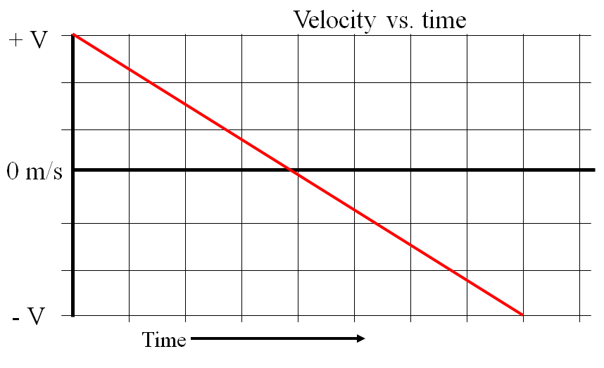

Example 1 - An object is launched straight up with a velocity of +33.0 m/s, and strikes the ground at the same elevation from which it is launched. Use the acceleration of gravity to be -9.81 m/s/s, and neglect air friction
- When is it at the top?
- How high does it go at the highest?
- What total time is it in the air?

- What is its velocity at an elevation of 45 m? At what times after launch does it reach this elevation?

- What is its velocity and displacement at 5.20 s after launch?

Example 2 - A piece falls off a rocket that is 27.0 m above the ground when the rocket is moving upwards at 21.0 m/s. Neglect air friction.
- Describe to your neighbor what the piece will do
- To what height does the piece rise above its release point before coming down?

- What is the velocity of impact of the piece with the ground?
- What time does the piece take to reach the ground?

