Noteguide for Velocity Graphs - Videos 2G Name

Slope of velocity graphs:
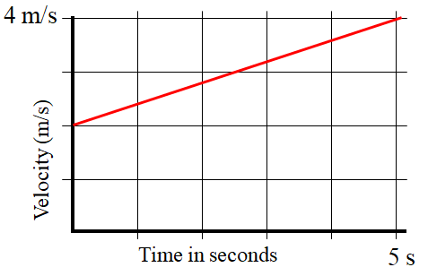
What does the slope on a velocity graph mean?

Whiteboards:
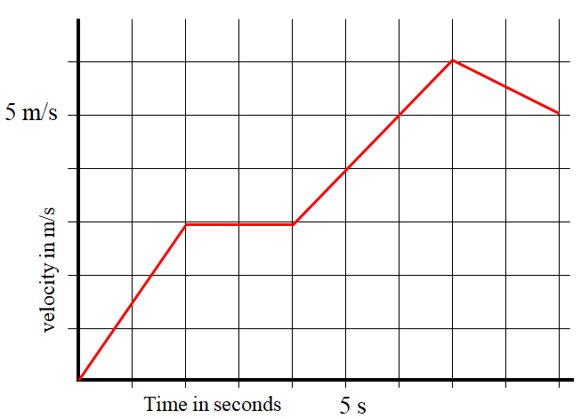
Keep in mind that when you find the slope, you should use the entire line segment.
1. What is the Acceleration at 1.15887 seconds? (1.5 m/s/s) | 2. What is the Acceleration at 8.1 s? (-0.50 m/s/s)
(In calculus the slope is the derivative)

Area under velocity graphs:

What does the area under a velocity graph mean?

Whiteboards:

"Area under" means the area between the graph and the x-axis. The units of this "area" are meters in this case, so it's not area in a strict sense. Graph areas can have all kinds of different units.
1. What displacement between 2 and 4 seconds? (6.0 m) | 2. What displacement between 4 and 7 seconds? (13.5 m)
(In calculus the area under is the integral)

