Noteguide for Displacement Graphs - Videos 2F Name

Slope on a position time graph:

Whiteboards:
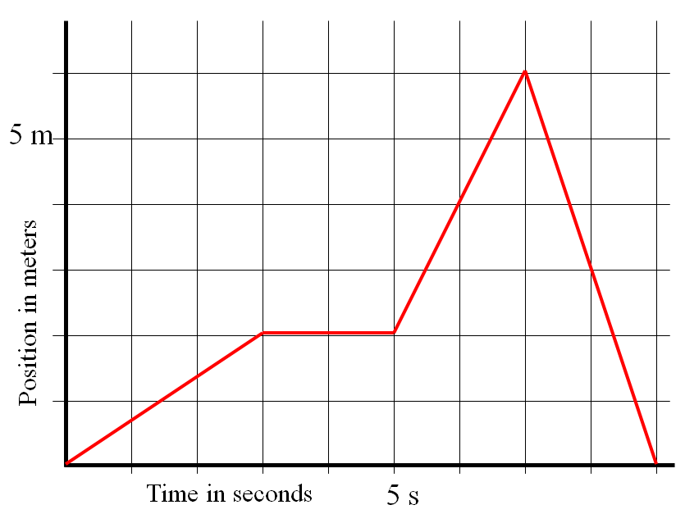
Keep in mind that when you find the slope, you should use the entire line segment. (i.e. 2.0 seconds, use the entire line from t = 0 to t = 3.0 s, and find the rise/run for that entire segment.)
1. What is the velocity at 2.0 s? (0.67 m/s) | 2. What is the velocity at 4.0 s? (0 m/s)
3. What is the velocity at 6.2 s? (2.0 m/s) | 4. What is the velocity at 8.15 s? (-3.0 m/s)

