Noteguide for Basic Wave Principles (Videos 12A, B, C) Name
Video 12A - two important principles:
Principle 1: | Principle 2:

Video 12B - Types of waves:
 | Wave moves | Particles move | Examples of
Transverse:

Longitudinal:

I have some demos and activities for this in class tomorrow

Video 12C - Wave Calculations - Period, Frequency, Wavelength, and Wave speed
Formula 1: | Formula 2:

 | Symbol | What it is | Units
Medium |  |  | N/A
Amplitude |  |  | Many answers
Wavelength

Wave speed

Period

Frequency

Example 1: What is the frequency of a wave that takes 0.12 s for the whole wave to pass by?

Example 2: What is the wavelength of an A 440.0 Hz if the speed of sound is 343 m/s?

Whiteboards:
1. What is the period of a 60. Hz wave? | 2. What is the frequency of a wave with a period of 0.003906 s
3. What is the velocity of a 1.12 m wave with a frequency of 32 Hz? | 4. What is the wavelength of a 89.1 MHz FM radio signal?  MHz = 10⁶ Hz  v = c = 3.00 x 10⁸ m/s (Speed of light)
5. What is the frequency of a sound wave that has a wavelength of 45 cm, where the speed of sound is 335 m/s | 6. What is the period of a 12.0 m long radio wave?  v = c = 3.00 x 10⁸ m/s (Speed of light) (These are EC on the test)

Noteguide for Reflections (Video 12D) Name

Occur when:

Examples of reflections:

How to prevent reflections:

Fixed vs. Free ends:

Mirrors:

Noteguide for Superposition and Interference (Videos 12E) Name
Superposition: (Overlapping waves add)
Examples:

Interference:
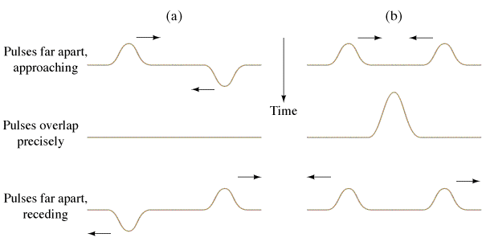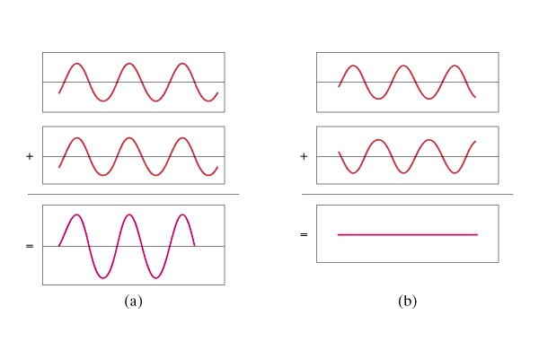

Wavelength rule for constructive interference: | Wavelength rule for destructive interference:

Other Examples:

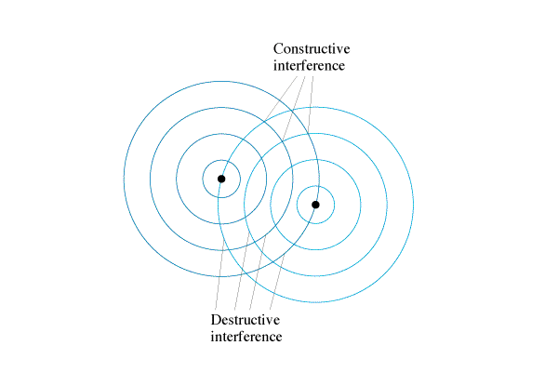

Noteguide for Standing Waves (Videos 12F, 12G Part 1) Name

Video F - Intro to standing waves
Watch the demos of all three kinds first
Draw the next two modes: (from the video)
Harmonic | Both ends fixed | Both ends free | One end fixed
1
2
3
Haha - we will talk in class why they happen. (I try to explain it on the video)

Video G - Part 1 - Calculations

One whole wavelength: 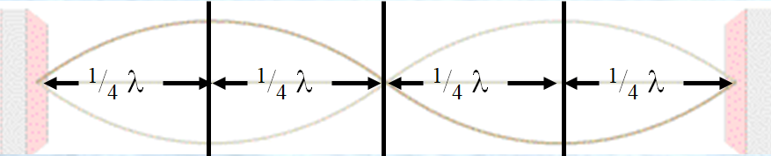

So a quarter wavelength is either:

OR Formulas:

So count the quarter wavelengths:

Formulas:
Example: This waveform is 8.45 m long. What is the wavelength of the standing wave? If it has a frequency of 30.4 Hz, what is the wave speed?

What is meant by the waveform: What is meant by the wavelength:

Do all of the examples
This waveform is 45 cm long. What is the wavelength? | The wavelength is 0.80 m long. What is the length of the standing wave? (The waveform)
This waveform is 2.42 m long. What is the wavelength? If it is a sound wave (v = 343 m/s), what is the frequency? | The wavelength is 124 cm long. What is the length of the waveform?  If it is a sound wave (v = 343 m/s), what is its frequency

Noteguide for Standing Waves (Videos 12G, Part 2) Name
Video G Part 2 - First three modes of vibration
This string is 32.0 cm long, and has a wave speed of 281.6 m/s. Find the wavelength and frequency for each mode:
 | Wavelength | Frequency
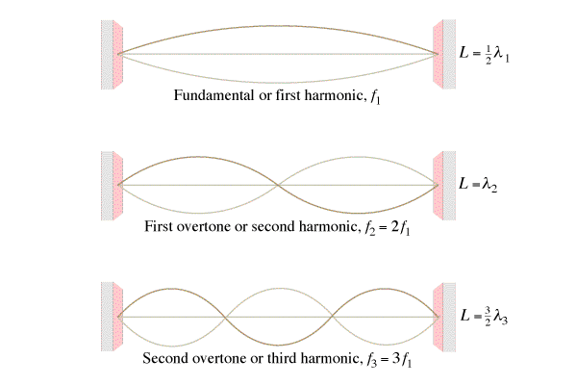
What is the pattern of frequencies:

This pipe is 1.715 m long, sound travels at 343 m/s along the pipe. Find the wavelength and frequency for each mode:
 | Wavelength | Frequency
What is the pattern of frequencies:

This pipe is 1.715 m long, sound travels at 343 m/s along the pipe. Find the wavelength and frequency for each mode:
 | Wavelength | Frequency
What is the pattern of frequencies:

Whiteboards:
1. The third harmonic on a flute (both ends open pipe) has a frequency of 480. Hz. How long is the waveform if the speed of sound inside the flute is 335 m/s? | 2. What is the frequency of the 2nd harmonic on a 0.31 m long pan pipe (One end open, one end closed) where the speed of sound is 343 m/s
3. What is the wave speed on a 0.34m long violin string if the first harmonic has a frequency of 440 Hz? | 4. What is the frequency of the 3rd harmonic on a violin string that is 0.34 m long where the wave speed is 299.2 m/s

Noteguide for Sound (Videos 12H) Name
What type of wave is sound:

Range of human hearing:

Most sound is:

v = (331 + 0.60T) m/s, T = temperature in ºC

Example 1 – What is the speed of sound at 20 ºC? 42 ºC?

Whiteboards:
1. What is the speed of sound in air at 80 ºC?  (379 m/s) | 2. At what temperature in Celsius is the speed of sound 318 m/s? (-21.7 ºC)

Noteguide for Beats (Videos 12I) Name
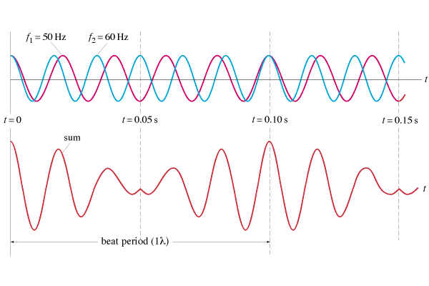

f_{beat} = |f₁ - f₂|

Examples:
1. I play a pitch of 256 Hz (C) on my Pennywhistle, and you play a pitch of 384 Hz (G) on your whistle. What is the beat frequency?

2. If I am playing a pitch of 384 Hz, and I hear a beat frequency of 10.0 Hz, what are the possible other frequencies that are playing?

Whiteboards:
1. What beats do you hear if you play an e 640 Hz with a c 1024 Hz?  (384 Hz, G in octave below the E ) | 2. If you are playing an A 440 Hz, and you hear a beat frequency of 20 Hz, what are the other possible frequencies that could be playing?  (460 Hz or 420 Hz )
3. The concertmaster is playing an A 440.0 Hz. Another violin hears a beat every 0.20 seconds. What frequency are they playing?
(445.0 Hz or 435.0 Hz )

Noteguide for Doppler (Videos 12K, 12L) Name

Video K - Introduction to Doppler (Watch all three videos)

Receding source/observer Approaching source/observer

Frequency is Frequency is

Video L - Feel free to skip the derivation if it does not interest you, but write down what all the variables are in the formulas:
Moving Source  f ':  f:  v:  u_{s:} | Moving Observer  f ':  f:  v:  u_{o:}

Do Examples 1 and 3. We will not be solving for source or observer speed, but it is extra credit on the test if you want to learn how to do it

Example 1 - A car with a 256 Hz horn approaches you at 40.0 m/s. What frequency do you hear? (3)  (use v sound = 343 m/s) | Example 3 - You run at 8.50 m/s toward a violinist playing 660. Hz. What frequency do you hear? (Use 343 m/s as the speed of sound)

