7.3 Quizlette - Gravity and Orbit Name
Gravity - Use G = 6.67x10⁻¹¹ Nm²/kg².
1. What is the force of gravity between a 3.50x10¹³ kg asteroid and a 29,300 kg spaceship if their centers are 1,720 m distant? (23.1 N)

2. What is the force of gravity between a 2.50x10¹⁴ kg asteroid and a 48,420 kg spaceship if their centers are 5,580 m distant? (25.9 N)

3. The centers of two lead spheres are separated by 2.70 m. If one sphere has a mass of 32.0 kg, and there is an attractive force of 1.70x10⁻⁹ N, what is the mass of the other sphere? (5.81 kg)

4. The centers of two lead spheres are separated by 1.55 m. If one sphere has a mass of 223 kg, and there is an attractive force of 1.90x10⁻⁸ N, what is the mass of the other sphere? (3.07 kg)

5. What distance separates the centers of two lead spheres if one has a mass of 502 kg, the other a mass of 56.0 kg and there is an attractive force of 2.60x10⁻¹² N? (849 m)

6. What distance separates the centers of two lead spheres if one has a mass of 215 kg, the other a mass of 197 kg and there is an attractive force of 2.40x10⁻⁸ N? (10.8 m)

Orbital Trajectories:
Questions: Answers:
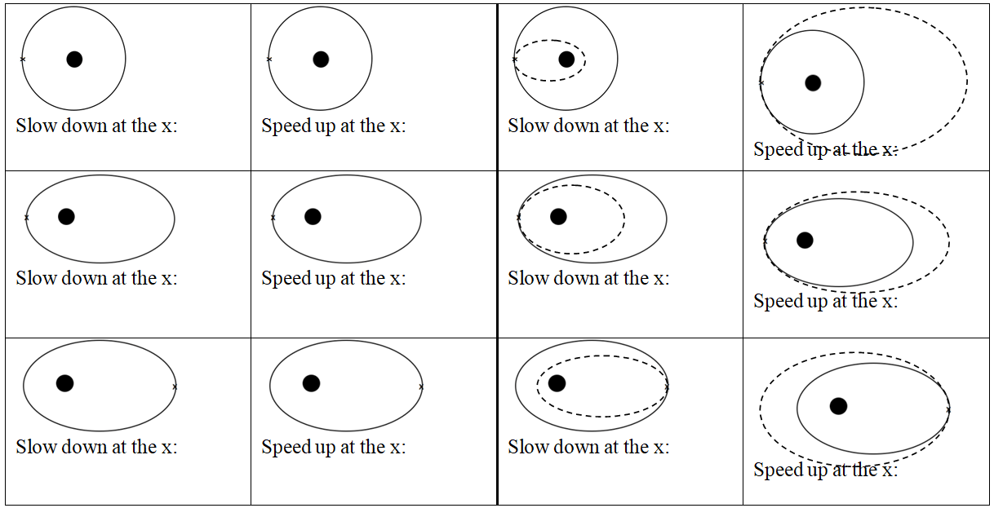
In general, speeding up brings the far side out, slowing down brings the far side in. Speeding up brings the entire trajectory outside the old one, and slowing down brings entire trajectory inside the old one.

Orbit:

Useful things to know:
Mass of the Earth | 5.97x10²⁴ kg | Radius of the Moon | 1.738x10⁶ m
Mass of the Moon | 7.35x10²² kg | Radius of the Earth | 6.38x10⁶ m
Mass of the Sun | 1.99x10³⁰ kg | Earth-Moon Distance | 3.84x10⁸ m
G = 6.67 x 10⁻¹¹ Nm²/kg² |  | Earth-Sun Distance | 1.496x10¹¹ m

1. What is the orbital velocity 3400 m from the center of a 5.6 x 10¹⁸ kg asteroid? (331.4 ≈ 330 m/s)

2. You find that you can orbit at 516 m/s 12,150 m from the center of a small moon. What is its mass? (4.85 x 10¹⁹ kg)

3. A satellite orbits a planet at a distance of 7.5 x 10⁶ m from the center every 8900 seconds. What is the mass of the planet? (3.2 x 10²⁴ kg)

4. What distance from the center of Earth’s moon is your orbital velocity 120 m/s? (3.4 x 10⁸ m)

5. What is the period of orbit of a satellite that orbits 1.95 x 10⁶ m from the center of Earth’s moon? (7730 s)

6. What is the radius of an orbit with a period of 3.16 x 10⁷ s around the sun? (1.50 x 10¹¹ m – yep – it’s the earth)

