Noteguide for Banked Corners: (Videos 7H) Name

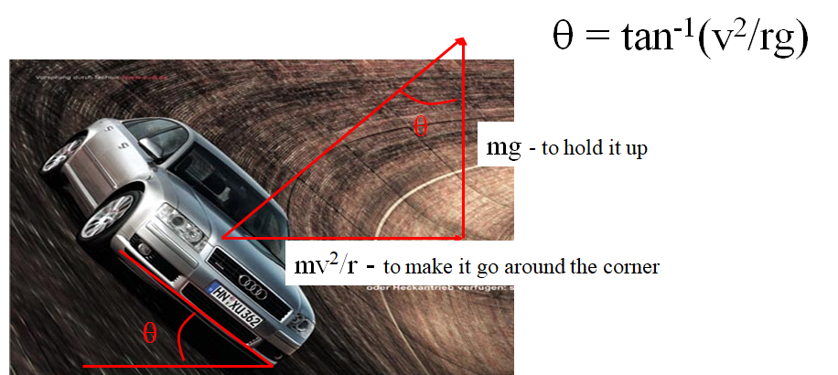

Example: The on ramp from onto I-5 from Nyberg is 40. m in radius maybe. What should be the bank angle to go 27 m/s around it?

Whiteboards:
1. One of the Terwilliger curves has a radius of 270 m. What is the bank angle for cars to go 29 m/s around it?  (18º) | 2. The on ramp from onto I-5 from Nyberg is 40. m in radius maybe. What should be the bank angle to go 45. m/s (101 mph) around it? (79º)  What about 112. m/s (250 mph) around it? (88º)  What does the angle approach? (90º)

