Noteguide for Kepler's Laws: (Videos 7G) Name
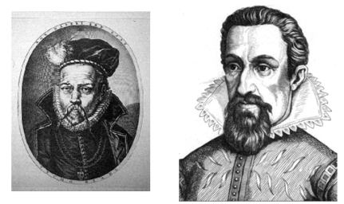
Johannes Kepler 1571 - 1630
Tycho Brahe 1546 - 1601

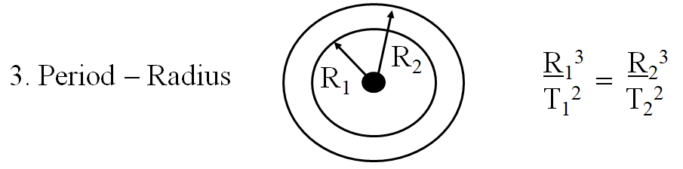

Example 1: What is the radius of a geostationary orbit (T = 1 day) if for
the moon T = 27.4 days, R = 3.8 x 10⁸ m

Example 2: Mars is 1.524 AUs from the sun. If our year is 365.26 days long, how many earth days is Mars's year?

