Noteguide for Vertical Circle – Videos 7C Name
Concept 0: a_{c} > 9.8 m/s/s so the string stays taut/water stays in cup
Show why this is true: | Example 1: What is the minimum speed at the top for my bucket if r = 1.12 m?  (So the cup does not fall off)
A roller coaster goes in a 3.8 m radius vertical circle. What is the minimum speed it can have at the top to stay on the rails?  (6.1 m/s) | What is the maximum radius you can twirl a bucket full of water going 2.3 m/s at the top? (0.54 m)

Concept 1: The “g” force of the ride adds to earth’s “g” force: (draw arrows to explain why)

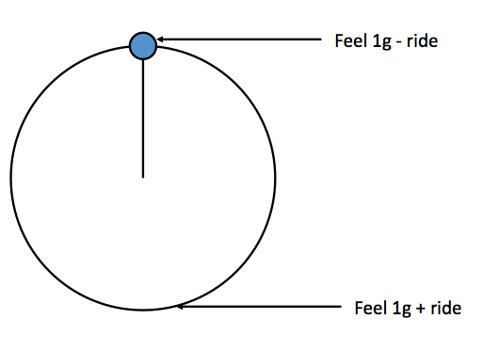
Whiteboards:
1. A Ferris Wheel pulls 0.2 “g”s. What is the “g” force at the top and the bottom? (0.80 “g”s top and 1.20 “g”s bottom) | 2. The Rock O Plane pulls 0.70 “g”s. What do you feel at the top and the bottom? (0.30 “g”s top, 1.70 “g”s bottom)
3. A Ferris wheel makes riders feel 0.70 “g”s at the top, and 1.30 “g”s at the bottom. What is the ride pulling? (0.30 “g”s) | 4. You feel 2.1 “g”s at the bottom of a roller coaster loop. What is the ride “pulling” and what do you feel at the top?  (1.1 “g”s ride, -0.10 “g”s top [inverted])

Example 1 – You calculate centripetal acceleration first:
A Ferris wheel has a radius of 9.40 m, and a period of 15.0 s. What is the acceleration of the ride in m/s/s and “g”s? What “g” force do they measure at the top and at the bottom?

Whiteboards:
1. A Ferris wheel makes riders go 4.08 m/s in an 8.50 m radius circle. What is the centripetal acceleration of the ride in “g”s? What do the riders feel at the top and the bottom?  (ac = 1.9584 m/s/s = 0.20 “g”s, 0.80 “g”s top, 1.20 “g”s bottom) | 2. A ride makes riders go in a 3.40 m radius vertical circle with a period of 2.93 s. What “g”s is the ride pulling, and what do the riders feel at the top and at the bottom?  (ac = 15.635 m/s/s = 1.60 “g”s, -0.60 “g”s inverted top, 2.60 “g”s bottom)

Example 2: - You calculate the “g”s first:
A rider moving in a 3.75 m radius vertical circle feels -1.2 “g”s (inverted “g”s) at the top of the circle. A) How many “g”s is the ride pulling? B) How many “g”s do they feel at the bottom?
C) What is their tangential velocity?

Whiteboards:
1 You are riding a rollercoaster, and you read an inverted “g” force of 0.75 “g”s at the top of a 3.8 m radius loop. (You are upside down!) (you feel -0.75 “g”s) A) How many “g”s is the ride pulling? B) What is that in m/s/s? C) What is your speed? (1.75 “g”s = 17.15 m/s/s. v = 8.07 m/s) | 2. A ride goes in a 5.0 m radius vertical circle. The ride itself pulls 1.80 “g”s. What do the riders feel at the bottom, and at the top, and what is the period of motion of the ride?  (2.80 “g”s bottom, -0.80 “g”s inverted top, T = 3.345 s)

