Noteguide for Centripetal Force (Videos 7B) Name
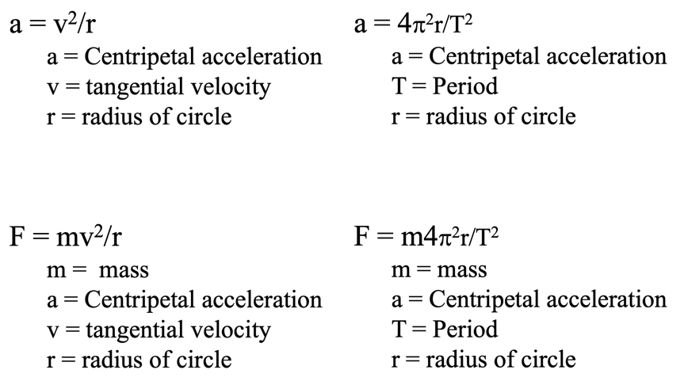
Example: What force is required to swing a 5.0kg object at 6.0m/s in a 75cm radius circle?

Example 2: A washing machine spin cycle has a radius of 42.0 cm and a period of 0.125 seconds. What force does it exert on a 0.215 kg piece of clothing?

Whiteboards:
1. Ice skates can give 420 N of turning force. What is r_{min} for a 50. kg skater @10.m/s? (11.9 m) | 2. A ride makes a 60 kg small redheaded child go in a 4.1m radius circle with a force of 470 N. What period? (4.5 s)
3. It takes 35 N of force to make a glob of Jell-O go in a 2.0 m radius circle with a period of 1.85 seconds What’s the mass? What’s its flavor? (1.5 kg)

Part 2 - Friction and Centripetal Force
Example - What is the centripetal acceleration of a 1200 kg car going 24 m/s around an 80. m radius corner? What centripetal force is needed? What is the minimum coefficient of friction needed?

A car has a coefficient of friction of 0.850 between the tires and the road. What is the minimum radius a corner can have if the car is travelling at 26.8 m/s (that’s about 60 mph) (86.2 m) | A 0.00217 kg eraser on a turntable is 6.70 cm (0.0670 m) from the center. If the period of motion is 0.750 s, what is the minimum coefficient of friction required between the eraser and the turntable? (0.480)
A 0.00425 kg eraser on a turntable is 8.50 cm (0.0850 m) from the center and has a coefficient of friction of 0.915 between itself and the turntable surface. What is the minimum period the turntable can have before the eraser slides off? (0.612 s)

