**Noteguide for Centripetal Acceleration (Videos 7A) Name**

Velocity = Speed + Direction

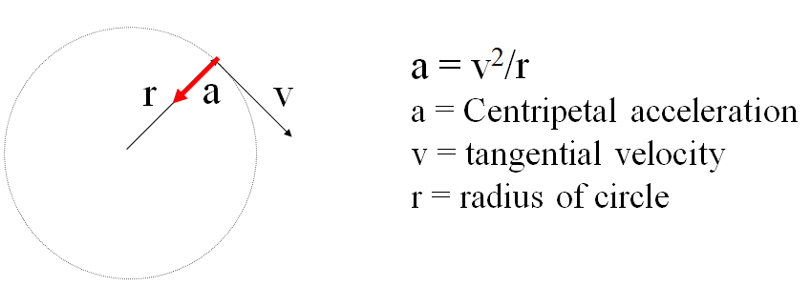

Example - What is the centripetal acceleration of a 1200 kg car going 24 m/s around an 80. m radius corner?

Whiteboards:

|  |  |
| --- | --- |
| 1. What is the centripetal acceleration if a tuna is going 6.2 m/s around a 2.3 m radius corner? (17 m/s/s) | 2. A carnival ride pulls an acceleration of 12 m/s/s. What speed in a 5.2 m radius circle? (7.9 m/s) |

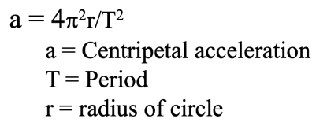Example: A merry-go-round completes a revolution every 7.15 seconds. What is your centripetal acceleration if you are 3.52 m from the center of rotation?

Whiteboard Example

|  |  |
| --- | --- |
| The Ferris wheel has a radius of 5.20 m, and a period of 11.5 s. What is its centripetal acceleration?  (1.55 m/s/s) | At what distance from the center of a merry-go-round with a period of 17.8 s is the centripetal acceleration 1.10 m/s/s? (8.83 m) |