**Noteguide for Centripetal Acceleration (Videos 7A) Name**

Velocity = Speed + Direction

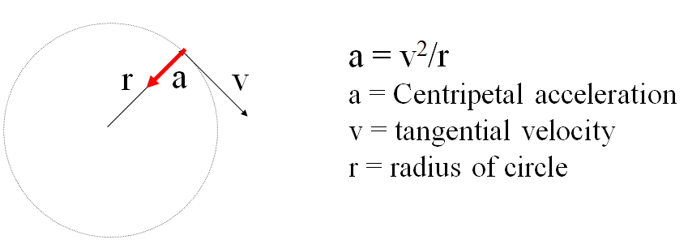

Example - What is the centripetal acceleration of a 1200 kg car going 24 m/s around an 80. m radius corner?

What centripetal force is needed? What is the minimum coefficient of static friction required?

Whiteboards:

|  |  |
| --- | --- |
| 1. What is the centripetal acceleration if a tuna is going 6.2 m/s around a 2.3 m radius corner? (17 m/s/s) | 2. A Volkswagen can do 0.650 “g”s (6.3765 m/s/s) of lateral acceleration. What is the minimum radius turn at 27.0 m/s? (114 m) |

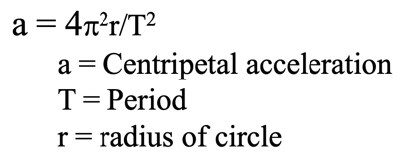Example: A merry-go-round completes a revolution every 7.15 seconds. What is your centripetal acceleration if you are 3.52 m from the center of rotation?

Whiteboard Example

|  |  |
| --- | --- |
| What should be the period of motion if you want 3.5 “g”s (34.335 m/s/s) of centripetal acceleration 5.25 m from the center of rotation? (2.5 s) | RPM Example: What is the acceleration of a point 32 cm out on a grinding wheel spinning at 1200 RPM?  (5035 m/s/s – hint – T = 60 s/1200 Rev) |

**Noteguide for Centripetal Force (Videos 7B) Name**

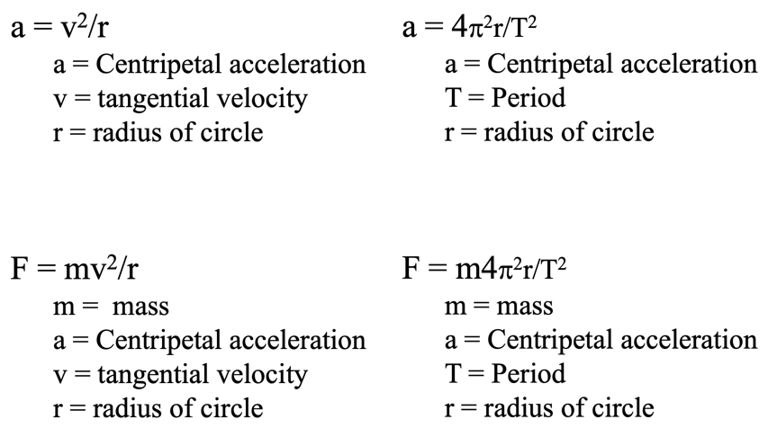

Example: What force is required to swing a 5.0kg object at 6.0m/s in a 75cm radius circle?

Whiteboards:

|  |  |
| --- | --- |
| 1. Ice skates can give 420 N of turning force. What is rmin for a 50. kg skater @10.m/s? (11.9 m) | 2. A ride makes a 60 kg small redheaded child go in a 4.1m radius circle with a force of 470 N. What period? (4.5 s) |
| 3. It takes 35 N of force to make a glob of Jell-O go in a 2.0 m radius circle with a period of 1.85 seconds What’s the mass? What’s its flavor? (1.5 kg) | |

**Noteguide for Vertical Circle – Videos 7C Name**

Concept 0: ac > 9.8 m/s/s so the string stays taut/water stays in cup

|  |  |
| --- | --- |
| Show why this is true: | Example 1: What is the minimum speed at the top for my bucket if r = 1.12 m?  (So the cup does not fall off) |
| A roller coaster goes in a 3.8 m radius vertical circle. What is the minimum speed it can have at the top to stay on the rails?  (6.1 m/s) | What is the maximum radius you can twirl a bucket full of water going 2.3 m/s at the top? (0.54 m) |

Concept 1: The “g” force of the ride adds to earth’s “g” force: (draw arrows to explain why)

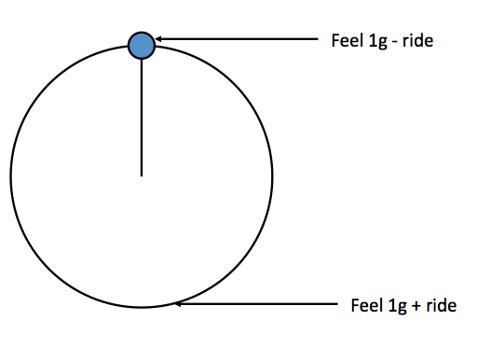

Whiteboards:

|  |  |
| --- | --- |
| 1. A Ferris Wheel pulls 0.2 “g”s. What is the “g” force at the top and the bottom? (0.80 “g”s top and 1.20 “g”s bottom) | 2. The Rock O Plane pulls 0.70 “g”s. What do you feel at the top and the bottom? (0.30 “g”s top, 1.70 “g”s bottom) |
| 3. A Ferris wheel makes riders feel 0.70 “g”s at the top, and 1.30 “g”s at the bottom. What is the ride pulling? (0.30 “g”s) | 4. You feel 2.1 “g”s at the bottom of a roller coaster loop. What is the ride “pulling” and what do you feel at the top?  (1.1 “g”s ride, -0.10 “g”s top [inverted]) |

**Example 1 – You calculate centripetal acceleration first:**

A Ferris wheel has a radius of 9.40 m, and a period of 15.0 s. What is the acceleration of the ride in m/s/s and “g”s? What “g” force do they measure at the top and at the bottom?

Whiteboards:

|  |  |
| --- | --- |
| 1. A Ferris wheel makes riders go 4.08 m/s in an 8.50 m radius circle. What is the centripetal acceleration of the ride in “g”s? What do the riders feel at the top and the bottom?  (ac = 1.9584 m/s/s = 0.20 “g”s, 0.80 “g”s top, 1.20 “g”s bottom) | 2. A ride makes riders go in a 3.40 m radius vertical circle with a period of 2.93 s. What “g”s is the ride pulling, and what do the riders feel at the top and at the bottom?  (ac = 15.635 m/s/s = 1.60 “g”s, -0.60 “g”s inverted top, 2.60 “g”s bottom) |

**Example 2: - You calculate the “g”s first:**

A rider moving in a 3.75 m radius vertical circle feels -1.2 “g”s (inverted “g”s) at the top of the circle. A) How many “g”s is the ride pulling? B) How many “g”s do they feel at the bottom?

C) What is their tangential velocity?

Whiteboards:

|  |  |
| --- | --- |
| 1 You are riding a rollercoaster, and you read an inverted “g” force of 0.75 “g”s at the top of a 3.8 m radius loop. (You are upside down!) (you feel -0.75 “g”s) A) How many “g”s is the ride pulling? B) What is that in m/s/s? C) What is your speed? (1.75 “g”s = 17.15 m/s/s. v = 8.07 m/s) | 2. A ride goes in a 5.0 m radius vertical circle. The ride itself pulls 1.80 “g”s. What do the riders feel at the bottom, and at the top, and what is the period of motion of the ride?  (2.80 “g”s bottom, -0.80 “g”s inverted top, T = 3.345 s) |

**Noteguide for Fundamental Forces: (Videos 7D) Name**

|  |  |
| --- | --- |
| Gravity | Weak Nuclear |
| Electro-Magnetic | Strong Nuclear |

Murray goes on a rant about how the short range nature of the Strong Nuclear (Binds neutrons and protons together) limits the number of stable nuclei (they get too big) and influences the number of neutrons.

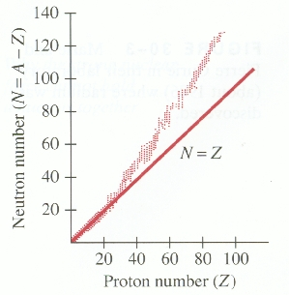

**Noteguide for Universal Gravitation: (Videos 7E) Name**

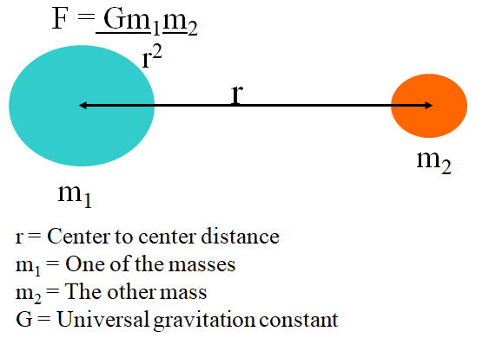

G = 6.67x10-11 Nm2/kg2

Example 1 - Find the force of gravity between a 0.756 kg stapler, and a 0.341 kg marker that is 1.75 m away?

Example 2 - What is the force of gravity between a 1.0 kg mass, and the earth?

(r = 6.38 x 106 m, mearth = 5.97 x 1024 kg)

Whiteboards:

|  |  |
| --- | --- |
| 1. What is the force of gravity between a 5.2 kg shot and a 250. kg wrecking ball whose centers are 2.45 m distant? (1.44 x 10-8 N) | 2. Another shot is 1.45 m from the center of a 250. kg wrecking ball and experiences a force of 1.55 x 10-7 N, what is the mass of the shot? (19.5 kg) |
| 3. What distance from the center of a 512 kg wrecking ball must a 4.5 kg bowling ball be to experience a force of 1.13 x 10-9 N? (11.7 m ) | 4. The moon has a mass of 7.36 x 1022 kg, and a radius of 1.74 x 106 m. What does a 34.2 kg mass weigh on the surface? (55.5 N) |

**Noteguide for Orbit problems - Videos 7F Name**

Use  or 

G = 6.67 x 10-11 Nm2/kg2

These come from these formulas:

  

Example 1 - What is the velocity of orbit 250 miles above the earth?

r = 6.38x106 m + (250 mi)(1609 m/mi) = 6782250 m, me = 5.97 x 1024 kg

Example 2 - What is the radius of a geosynchronous orbit?

T = 23:56:04 = 23(3600) + 56(60) + 4 = 86164 s, me = 5.97 x 1024 kg

Fill in the Solutions:

|  |  |
| --- | --- |
| **Formula:** | **Calculator:** |
| v = |  |
| mc = |  |
| r = |  |

|  |  |
| --- | --- |
| **Formula:** | **Calculator:** |
| T = |  |
| mc = |  |
| r = |  |

**Noteguide for Kepler's Laws: (Videos 7G) Name**

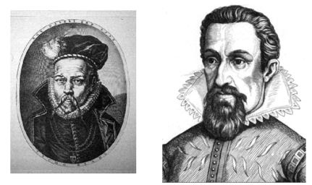

**Johannes Kepler 1571 - 1630**

**Tycho Brahe 1546 - 1601**

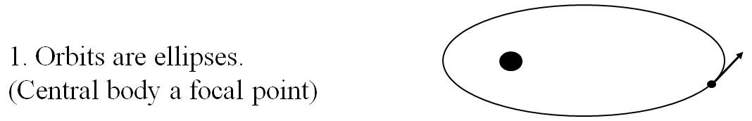

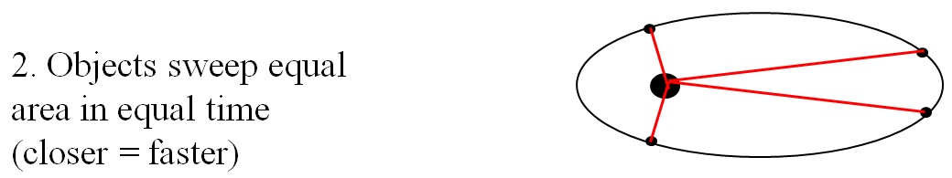

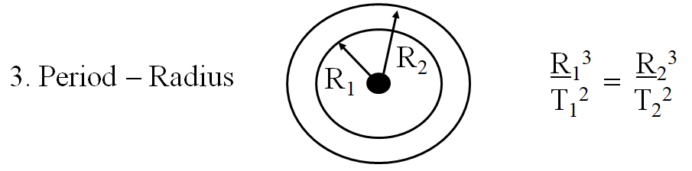

Example 1: What is the radius of a geostationary orbit (T = 1 day) if for

the moon T = 27.4 days, R = 3.8 x 108 m

Example 2: Mars is 1.524 AUs from the sun. If our year is 365.26 days long, how many earth days is Mars's year?

**Noteguide for Banked Corners: (Videos 7H) Name**

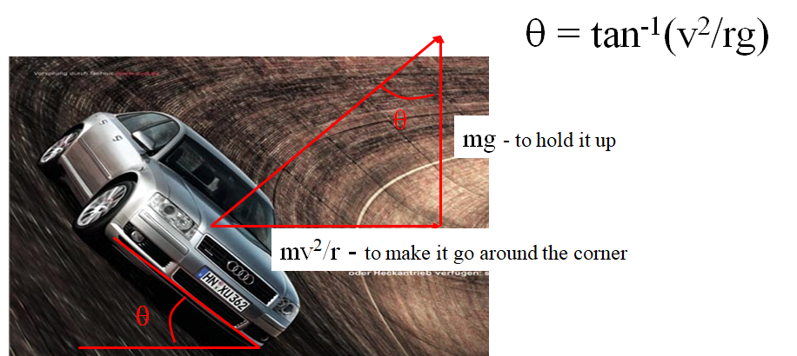

Example: The on ramp from onto I-5 from Nyberg is 40. m in radius maybe. What should be the bank angle to go 27 m/s around it?

Whiteboards:

|  |  |
| --- | --- |
| 1. One of the Terwilliger curves has a radius of 270 m. What is the bank angle for cars to go 29 m/s around it?  (18o) | 2. The on ramp from onto I-5 from Nyberg is 40. m in radius maybe. What should be the bank angle to go 45. m/s (101 mph) around it? (79o)  What about 112. m/s (250 mph) around it? (88o)  What does the angle approach? (90o) |