Physics
FA 7.3 – Orbit and Gravity
Name
Show your work, round to the correct significant figures, circle your answers, and label them with units.
When you have finished this, go to the website and check your answers. If you got a problem wrong, cross it off on the front, and do it correctly on the back.
1. What is the force of gravity between the Philae probe with a mass of 100. kg and comet 67P with a mass of 1.05x10¹³ kg if the probe is resting on the surface of the 2.05 km (2.05x10³ m) radius comet. (That we will pretend is spherical - it's highly not)

2. What distance needs to separate the centers of two 5.20 kg spheres so that the force of gravity between them is 1.20x10⁻⁹ N

3. Your 12,500 kg spaceship is orbiting 1.16x10⁷ m from the center of a planet every 17,500 s. What is the mass of the planet?

4. At what distance from the center of our 7.35x10²² kg moon is the orbital velocity 340. m/s?

5. Draw the new orbit: (Circle or oval indicates your current orbit)
Slow at x: Speed up at x: Speed up at x:
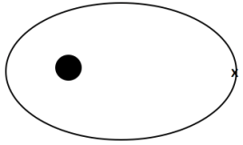
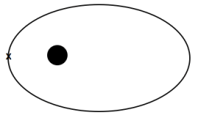
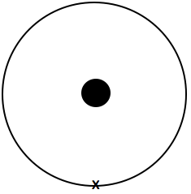
(elliptical, inside, tangent at x) (more elliptical, outside orbit, tangent at x) (less elliptical, outside orbit, tangent at x)

