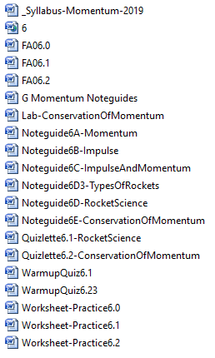
Physics G
Momentum
(Chapter 6 Syllabus)
A/B | In Class: | Due on this class:
1  Apr  2/3 | GW-Momentum exploration  GW-P6.0 1-3, 6, 7-9, 13-15  GW-FA6.0 | VF 6A,6 B, 6C  Turn in P6.0:1-3, 6, 7-9, 13-15
2  Apr  4/5 | SA6.0-Impulse and Momentum (first 30)  VF-6D Rocket Science  DI-Rocket Demos | Turn in FA6.0
3  Apr  8/9 | GW-Rocket Science Quizlette (6.1) | VF 6D (finish it up)  Turn in Rocket Science Quizlette 6.1
4  Apr  10/11 | SA6.1-Rocket Science (first 30)  VF-6E – Conservation of Momentum | Turn In FA6.1
5  Apr  15/16 | DI-Physics Cannon  GW-COM Quizlette 6.2  GW-COM Lab | VF 6E (finish it up)  VF Conservation of momentum lab (First video)  Turn in Physics Cannon Lab
6  Apr  17/18 | DI-Demos part 1  Transmogrification  Rubber bullets/Pelton  Explosions  GW-COM Quizlette 6.2  GW-COM Lab
7  Apr  19/22 | DI-Demos part 2  Re-inventing the automobile  Match rockets  GW-COM Quizlette 6.2  GW-COM Lab
8  Apr  23/24 | SA6.2-Conservation of Momentum (first 30)  VF-12A, 12B, 12C | Turn in Conservation of Momentum Lab
1  Apr  25/26 | Vaves, Ja!! | VF-12A, 12B, 12C
Assignments:
- 2 Labs:
  - Clocking the Physics Cannon lab – (in class) /20 pts
  - Conservation of Momentum lab – (on air track) /30 pts
- 3 Formative/Summative assessments (10 pts each)
  - 6.0 Impulse and Momentum
  - 6.1: Rocket Science
  - 6.2: Conservation of Momentum

