Noteguide for Conservation of Momentum - Videos 6E Name

Part 1 - Why Momentum must be conserved
Write down a proof that momentum must be conserved:

Example: 60. kg Sally going 4.5 m/s collides head on with 80. kg Bob who is going 2.3 m/s.

Three steps: The diagram and problem

Part 2 - Do the first four example problems below the first video: See if you can figure them out first, but if you can't, play the video...
Example 1
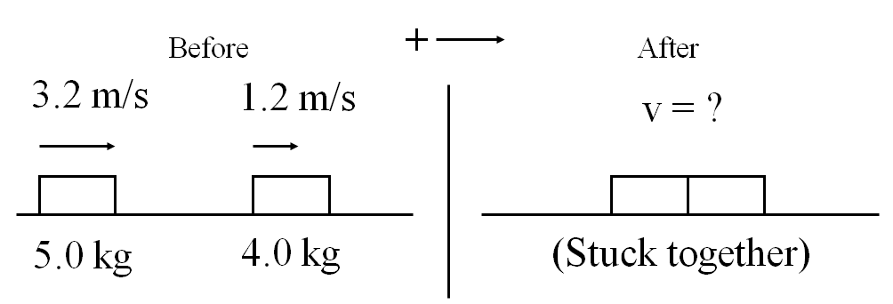
(2.3 m/s)

Example 2
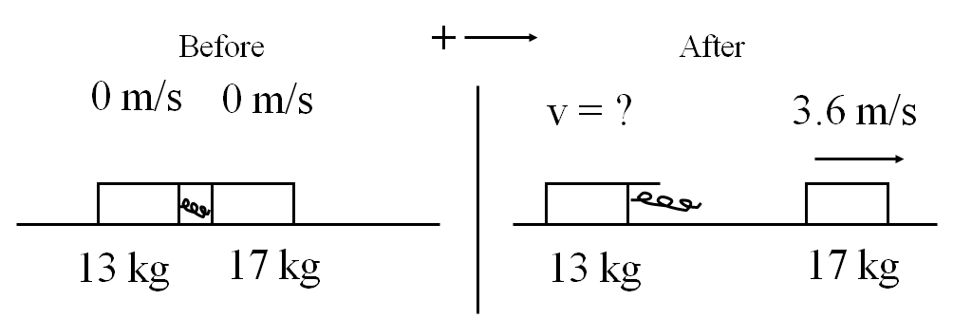
(-4.7 m/s)
(left)

Example 3
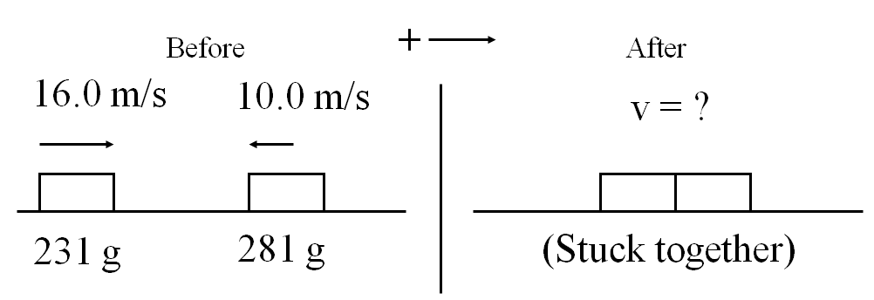
(1.73 m/s)

Example 4
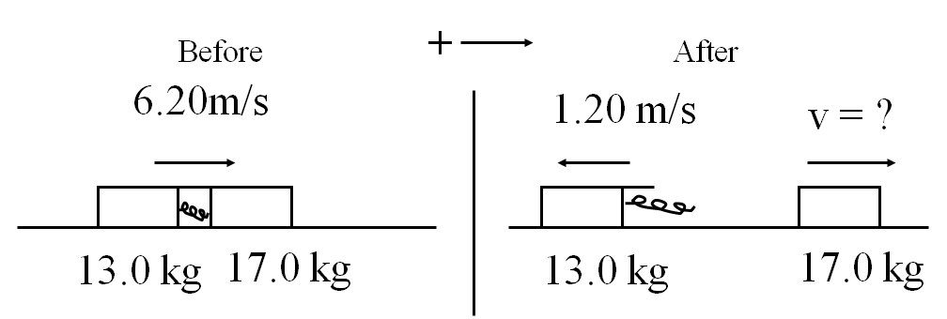
(11.9 m/s)

