Noteguide Impulse - Videos 6B Name
Write down the formula for impulse: (Be sure to write down what all the symbols mean, and their units)

Impulse =

Example: What impulse is imparted by exerting a 12 N force for 4.0 s?

Example: Impulse is the area under a F vs. t graph
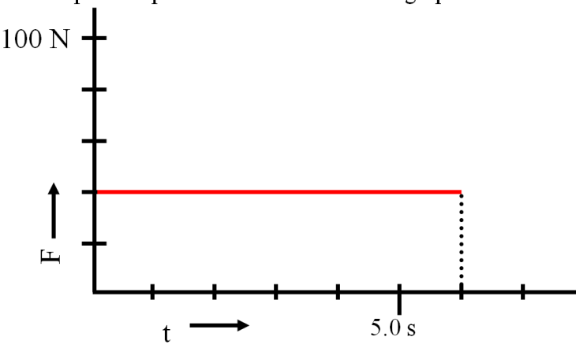
Show your calculation here:

Whiteboards:
1. What is the impulse of a 6.12 N force acting for 2.3 seconds?  (14 Ns) | 2. A rocket engine is rated at 14 Ns of impulse, and burns for 1.7 seconds. What is the thrust of the engine?  (8.2 N)
3. What is the impulse? (Area under the line)  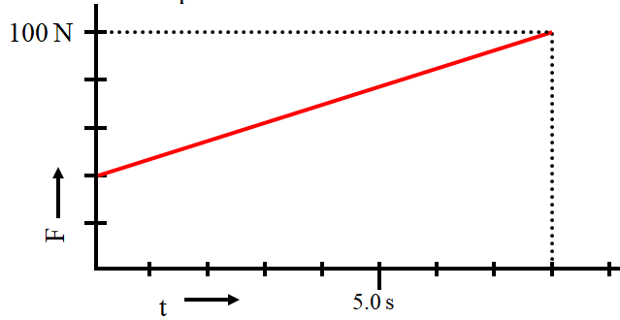  (560 Ns) | 4. What is the impulse? (Area under the line)  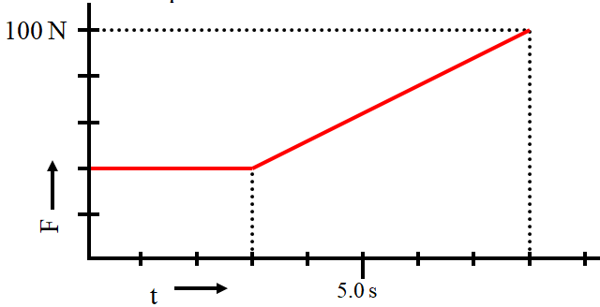  (470 Ns)

