Noteguide Momentum - Videos 6A Name
Videos 6A - Momentum
What does Momentum mean:

Write down the formula for momentum: (Be sure to write down what all the symbols mean, and their units)

p =

Example: What is the momentum of a 145 g baseball going 40. m/s:

Example: 60 kg Fran is running at 4 m/s when she collides with 80 kg Joe head on. They hit and stop dead, so how fast was Joe going?

Whiteboards:
1. What is the momentum of a 22 g swallow going 5.2 m/s  (0.11 kg m/s) | 2. What velocity must a 6.5 gram bullet have for its momentum to be 5.8 kgm/s?  (890 m/s)
3. A bowling ball has a momentum of 43.6 kgm/s when it is going 12 m/s. What is its mass?  (3.6 kg) | Draw a picture of pretty flower here:

Noteguide Impulse - Videos 6B Name
Write down the formula for impulse: (Be sure to write down what all the symbols mean, and their units)

Impulse =

Example: What impulse is imparted by exerting a 12 N force for 4.0 s?

Example: Impulse is the area under a F vs. t graph
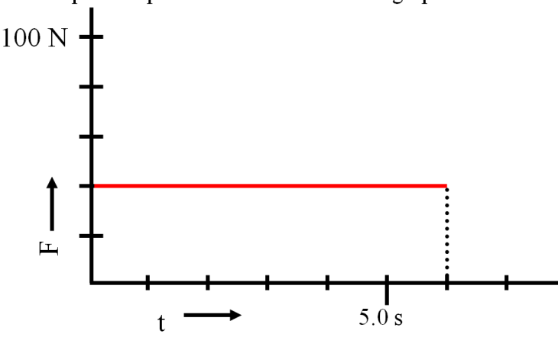
Show your calculation here:

Whiteboards:
1. What is the impulse of a 6.12 N force acting for 2.3 seconds?  (14 Ns) | 2. A rocket engine is rated at 14 Ns of impulse, and burns for 1.7 seconds. What is the thrust of the engine?  (8.2 N)
3. What is the impulse? (Area under the line)  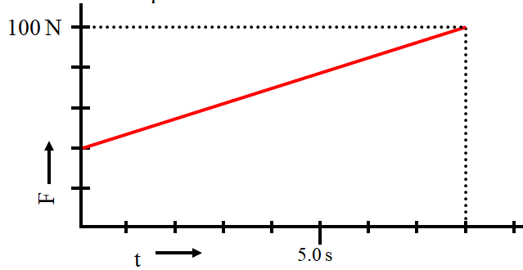  (560 Ns) | 4. What is the impulse? (Area under the line)  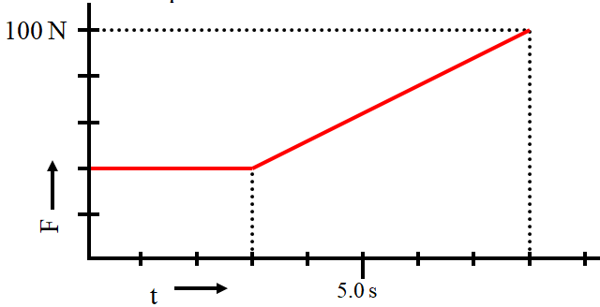  (470 Ns)

Noteguide Impulse and Momentum - Videos 6C Name
Write down what these symbols are below:

Impulse = F Δt = m Δv

Example: A pitcher pitches a 0.145 kg baseball at +40. m/s, and the batter hits it directly back at -50. m/s to the outfield. What is the average force exerted by the bat if the collision lasted 0.013 s? (-1.0E3N)

Why Δv is tricky:

Whiteboards:
What force for 10. seconds makes a 2.0 kg rocket speed up to 75 m/s from rest?  (15 N) | A baseball bat exerts a force of 200. N on a 0.50 kg ball for 0.10 seconds. What is the ball’s change in velocity?  (40 m/s)
Jolene exerts a 50. N force for 3.0 seconds on a stage set. It speeds up from rest to .25 m/s. What is the mass of the set?  (600 kg) | Draw a cartoon dog here:

Deriving Newton's Second law: (Write down the math steps from the last video)

Noteguide for Rocket Science - Videos 6D Name
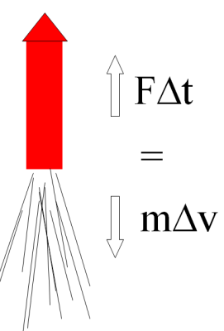
Write down what these are in terms of Rockets:

F Δt = m Δv

F =
Δt =
m =
Δv =

Example 1: A rocket burns fuel at a rate of 1.2 kg/s, with an exhaust velocity of 1250 m/s. What thrust does it develop?

Example 2: A model rocket engine develops 12.0 N of thrust with an exhaust velocity of 718 m/s. What is its fuel burn rate?

What is the rocket’s initial acceleration if it has a mass of 238 g?

Whiteboards:
A certain rocket engine burns 0.0352 kg of fuel per second with an exhaust velocity of 725 m/s. What thrust does it generate?  (25.5 N) | The Saturn V’s first stage engines generated 33.82 MN of thrust (33.82 x 10⁶ N) with an exhaust velocity of 2254.7 m/s. What was its fuel burn rate?  (15,000 kg/s)
A D12 engine generates 11.80 N of thrust burning fuel at a rate of 0.0143 kg/s. What is the exhaust velocity?
If the rocket has a mass of 139 grams, what is the initial upward acceleration?
(825 m/s, 75.1 m/s/s)

Draw a picture of a pretty pony here:

Vertical Acceleration of a Rocket

What are the 4 steps for solving these:

1.

2.

3.

4.

Example 1: A rocket has a total mass of 12.0 kg, 10.0 kg of which is fuel. It consumes all of its fuel in 8.50 seconds with an exhaust velocity of 420. m/s What are its initial and final accelerations?

Example 2: A 21.0 kg rocket, 16.0 kg of which is fuel, burns its fuel at a rate of 0.820 kg/s with an exhaust velocity of 730. m/s. What are its initial and final acceleration as it takes off from earth?

Noteguide for Types of Rockets - Videos 6E part 3 Name
Solid Fuel:
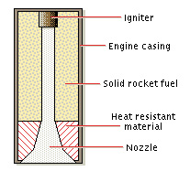

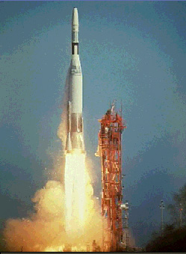
Liquid Fuel:
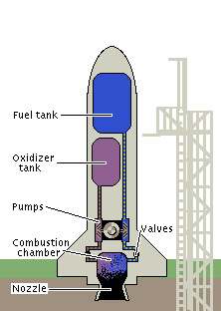
How do you keep from tipping?

Why is there "Steam" coming off the rocket

Saturn V rocket:
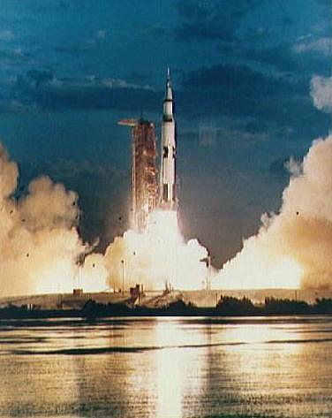
Label the diagram on the right

What is the main advantage of having multiple stages?

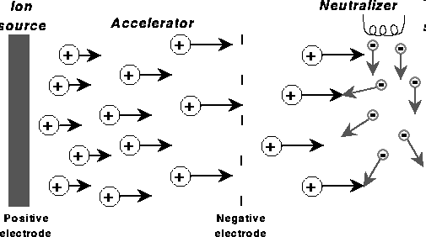
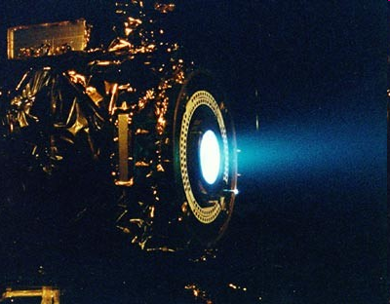
Ion Propulsion

Where does an ion drive get its energy?

Noteguide for Conservation of Momentum - Videos 6E Name

Part 1 - Why Momentum must be conserved
Write down a proof that momentum must be conserved:
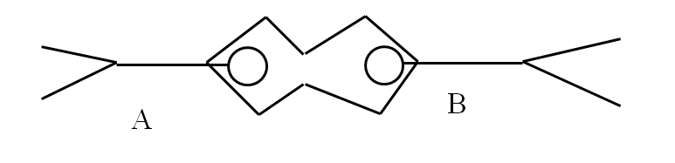

Example: 60. kg Sally going 4.5 m/s collides head on with 80. kg Bob who is going 2.3 m/s.

Three steps: The diagram and problem

Part 2 - Do the first four example problems below the first video: See if you can figure them out first, but if you can't, play the video...
Example 1
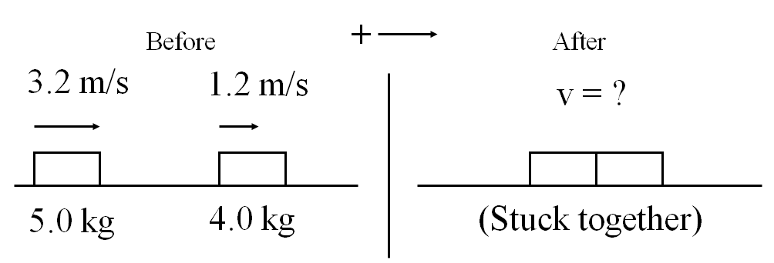
(2.3 m/s)

Example 2
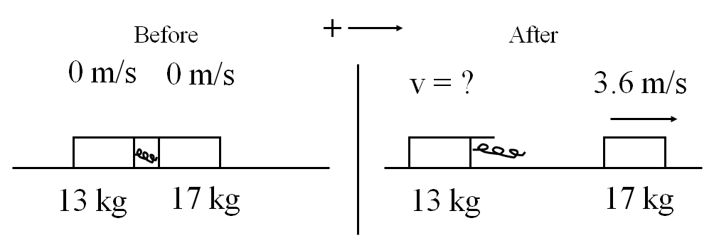
(-4.7 m/s)
(left)

Example 3
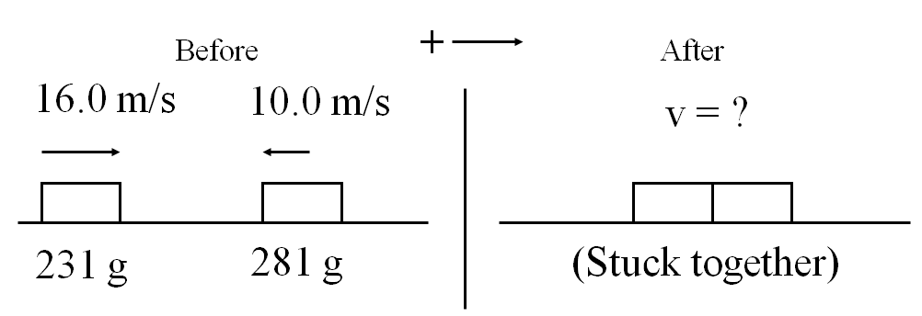
(1.73 m/s)

Example 4
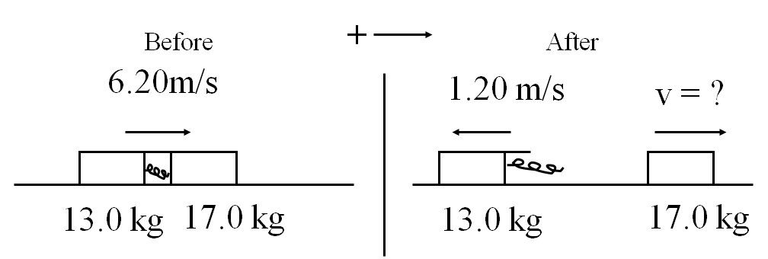
(11.9 m/s)

