Noteguide for Kinetic Energy - Videos 5G Name

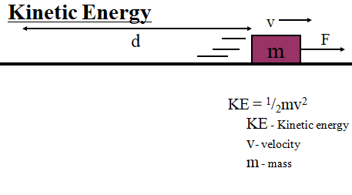

Example: What is the kinetic energy of a 4.20 g bullet going 965 m/s? (units?)

Whiteboards:
1. Ex1 - What speed must a .563 kg hammer move to store 34 J of energy? (11 m/s) | 2. Ex2 - A European swallow has 2.055 J of kinetic energy when it is flying at 14.23 m/s. What is its mass in grams?  (0.020297 kg, 20.3 g)
3. Ex3 - A 4.0 kg shot is sped up from 6.0 m/s to 9.0 m/s. What is the change in kinetic energy?
(90 J) - (calculate two KEs and subtract)

