Noteguide for Efficiency - Videos 5D Name

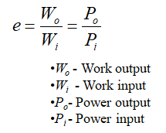
Example - 1 HP motor consumes 815 W of power

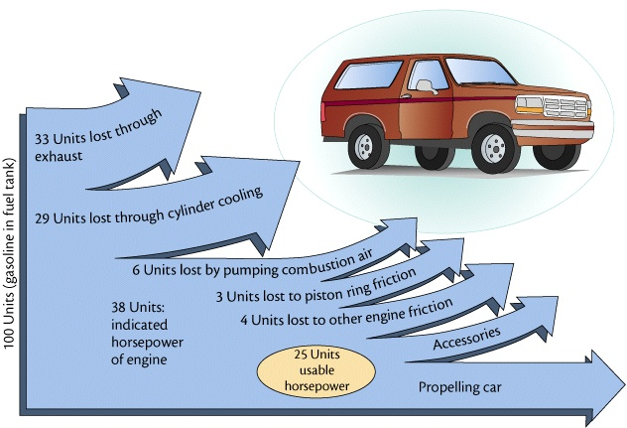

Whiteboards:
1. A motor consumes 425 J of energy and does 300 J of work. e = ? (0.71, or 71%) | 2. A person is 13% efficient. How much food energy to do 600. J of work? (4615 J)
3. A 60.% efficient heater uses 800. J of energy. What is its heat output? (480 J) | 4. A car is 25% efficient. What energy input does it need to climb a 320 m tall hill if its mass is 1200 kg? (15,052,800 J) (Hint - Wo = (F)d = (mg)h )

