**Noteguide for Work and Power JAMBALAYA - Videos 5C Name**

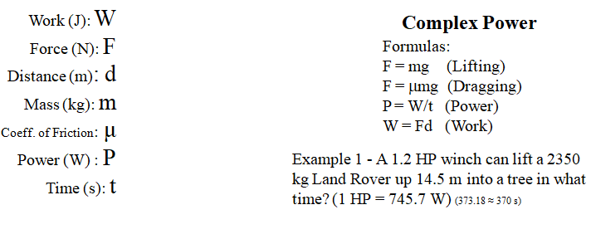

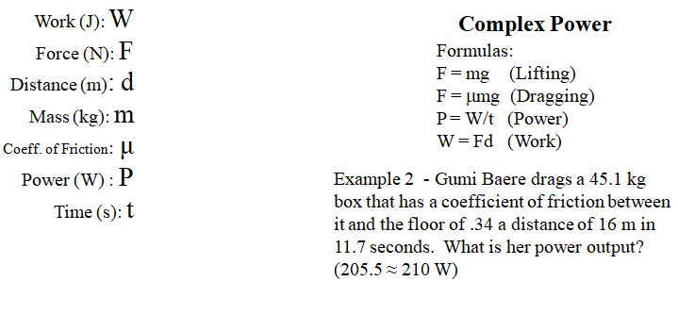

(do the whiteboards on the back)

Whiteboards:

|  |
| --- |
|  |
|  |
|  |
|  |