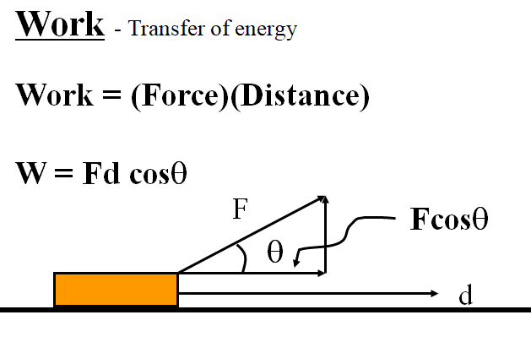
Noteguide for Work - Videos 5A Name

Example - Fred O’Dadark exerts 13.2 N on a rope that makes a 32º angle with the ground, sliding a sled 12.5 m along the ground. What work did he do?

Work and Weight Example – Joe Dadi lifts a 5.0 kg mass 2.5 m. What work does he do?

W
F
d
m
μ
F = mg (lifting)
F = μmg (dragging)
W = Fd

Work and Friction Example – Herman Leftur drags a 150 kg sled 45 m across a lake where the coefficient of kinetic friction is 0.12. How much work does he do?

W
F
d
m
μ
F = mg (lifting)
F = μmg (dragging)
W = Fd

(Do the whiteboards on the back)

Whiteboards (simple work)
1. Jane Linkfence does 132 J of work lifting a box 1.56 m. What is the weight of the box? (What force did she exert?) (84.6 N) | 2. Bob White does 2,345 J of work pushing a car with a force of 186 N of force. What distance did he push the car? (12.6 m)
3. Helena Handbasket brings a 5.2 kg box down from a 1.45 m tall shelf. What work does she do?
(-74 J)

Work and Weight:
4. Paul E. Wannacracker does 2375 J of work lifting what mass a height of 1.18 m? (205.4 kg) | 5. Tubi O’ Notubi does 137 J of work lifting a 5.25 kg mass to what height? (2.66 m)

Work and Friction:
6. Hugh Jazz drags a 125 kg sled with a coefficient of kinetic friction of .15 a distance of 34 m. What work does he do? | 7. Seymour Butz does 1200 J of work dragging a 32 kg box with a coefficient of kinetic friction of .21 how far?

