Noteguide on Conservation of Energy - Videos K from Chapter 5

Video K - Introduction to Conservation of Energy

Part 1 - What is the basic concept behind Conservation of Energy? What are two other ways to frame it?

Basic Concept:

Another way:

Another way:

Giant Formula: Fd + mgh + ¹/₂mv² = Fd + mgh + ¹/₂mv²

Be sure to note how to tell which side the Fd is on (it has to do with speeding up and slowing down)

Example: A 250 kg cart going 4.5 m/s rolls down a 1.75 m tall hill. What is the velocity of the cart at the bottom?
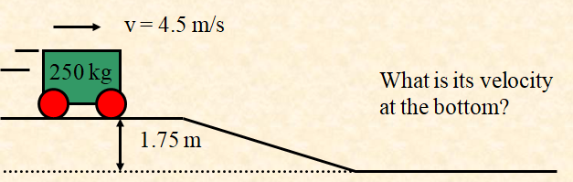

Fd + mgh + ¹/₂mv² = Fd + mgh + ¹/₂mv²

Listen carefully to the explanation - specifically -
Why is there no Fd in the whole problem?
How do we know there is KE (¹/₂mv²) at the top? How do we know there is PE (mgh) at the top?
How do we know that there is only KE at the bottom?

Look at least at the first two example problems:
Example 1 - An 890 kg cart rolling 6.2 m/s along a level surface hits a 3.6 m long puddle that exerts 3200 N of average retarding force. What is the cart’s velocity after this?
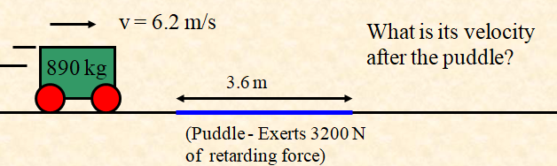

Fd + mgh + ¹/₂mv² = Fd + mgh + ¹/₂mv²

Example 2 - A 350 kg cart is going 4.6 m/s. For what distance must a person exert a forward force of 53 N so that when the cart gets to the top of a 1.8 m tall hill it is going 2.4 m/s?
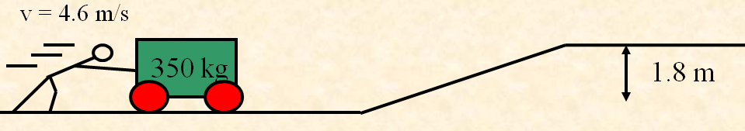

Fd + mgh + ¹/₂mv² = Fd + mgh + ¹/₂mv²

