5.1 - Jambalette!!! - Work, Power, Force Name
Efficiency: $e=\frac{o}{i}$ 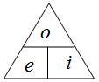
1) A heater consumes 1210 J of energy from natural gas, and puts out 1150 J of heat into the home. What is its efficiency?

2) An electric motor is 91.0 % efficient. What is its power output if it consumes 832 W of electrical power?

3) A car is 23.0 % efficient. If it does 13,200 J of work, what energy in fuel does it consume? If it consumes 4,230 J of fuel, what work does it do?

1) 0.950 or 95.0 %, 2) 757 W, 3) 57,391 J, 972.9 J, 4) 142 W, 5) 21.5 s, 6) 2400 J

Power: $P=\frac{W}{t}$ 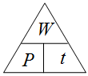
4) A heater puts out 340. J of heat in 2.40 s. What is its power?

5) A 210. W motor does 4,520 J of work in what time?

6) A 40.0 W light bulb consumes what energy in a minute (60 s)?

Jambalaya!! W = Fd, $P=\frac{W}{t}$, F = mg or F = μmg
Two step problems: 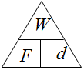, , 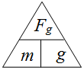 or 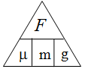
7) What work is it to drag a 12.0 kg box 17.0 m across the floor where the coefficient of friction is 0.210?

8) A winch does 732 J of work lifting what mass to a height of 3.20 m?

9) Sled dogs do 11,300 J of work dragging a 117 kg sled 75.8 m. What is the coefficient of friction?

Three Step:
10) A survivor contestant drags a 125 kg box 214 m across a surface with a coefficient of friction of
0.170 in 145 s. What is their power output?

7) 419.8 J, 8) 23.3 kg, 9) 0.130, 10) 307 W, 11) 89.5 s, 12) 224 s, 13) 44,283 W

11) What is the minimum time a 746 W motor can lift a 2130 kg Land Rover 3.20 m?

12) A sled dog team has a power output of 895. W. In what time can it drag a 141 kg sled 1,320 m
across a frozen lake where the coefficient of friction is 0.110?

13) An elevator motor must lift a 3,210 kg elevator 18.3 m in 13.0 s. What is its minimum power rating?

Physics
FA5.1 - Efficiency and Power
Name

Favorite YouTube video (besides physics)
Show your work, and circle your answers and use sig figs to receive full credit.
1. If a heater is 78.0% efficient, how much fuel energy would it consume to provide 120. J of useful heat? How much useful heat could it produce from 360. J of fuel energy?

2. How much time does it take for a 450. Watt heater to produce 4580 J of heat? What heat will it put out in 32.0 s?

3. What work would you do dragging a 56.5 kg box 12.0 m over a level floor (at a constant low speed) where the coefficient of dynamic friction is 0.215?

4. What is the minimum power rating a motor could have if it is to lift a 560. kg elevator 35.0 m in 78.0 seconds?

Efficiency and Power Questions from A5.1 (optional)
0.856, 380. J  45.0 W, 2700 J  9.32 m  282 s | 1. a. A heater consumes 125 J of fuel and produces 107 J of useful heat. What is its efficiency? How much fuel would it consume to produce 325 J of useful heat?  b. A motor does 585 J of work in 13.0 seconds. What is its power output? What work could it do in 60.0 seconds?  c. You do 412 J of work dragging a 26.5 kg box over a level floor (at a constant low speed) where the coefficient of dynamic friction is 0.170. What distance did you drag it?  d. What is the minimum time a 540. W motor can lift a 3450 kg land rover 4.50 m?
567 J, 408 J  80.4 W, 19.0 s  3.21 m  405 W | 2. a. A heater is 91.0% efficient. How much useful heat would it produce from 623 J of fuel energy? How much fuel would it consume to produce 371 J of useful heat?  b. A motor does 965 J of work in 12.0 seconds. What is its power output? In what time could it do 1530 J of work?  c. You do 371 J of work lifting a 11.8 kg box. What height did you lift it?  d. What is your power output if you drag a 87.0 kg sled a level distance of 43.0 m in 19.0 s where the coefficient of dynamic friction is 0.210?
0.916, 591 J  5040 J, 1.80 s  9.97 kg  43.8 s | 3. a. A heater consumes 215 J of fuel and produces 197 J of useful heat. What is its efficiency? How much useful heat would it produce from 645 J of fuel energy?  b. What work does a 420. W motor do in 12.0 seconds? What time would it take the motor to do 758 J of work?  c. You do 850. J of work raising what mass a vertical distance of 8.70 m?  d. A sled dog has a power output of 310. W. In what time can it drag a 112 kg sled 95.0 m across a frozen lake where the coefficient of friction is 0.130?
204 J, 584 J  51.6 W, 6970 J  15.0 kg  674 W | 4. a. A heater is 82.0% efficient. How much fuel would it consume to produce 167 J of useful heat? How much useful heat would it produce from 712 J of fuel energy?  b. A motor does 568 J of work in 11.0 seconds. What is its power output? What work could it do in 135. seconds?  c. You do 381 J of work dragging a box 23.5 m over a level floor (at a constant low speed) where the coefficient of dynamic friction is 0.110. What is the mass of the box?  d. What is the minimum power rating a motor can have if it needs to lift a 2350 kg SUV a vertical distance of 4.50 m in 154 s?
0.945, 912 J  1890 J, 7.00 s  0.137  135 s | 5. a. A heater consumes 618 J of fuel and produces 584 J of useful heat. What is its efficiency? How much fuel would it consume to produce 862. J of useful heat?  b. What work does a 118 W motor do in 16.0 seconds? What time would it take the motor to do 826 J of work?  c. You do 645 J of work dragging a 15.0 kg box over a level floor (at a constant low speed) a distance of 32.0 m. What was the dynamic coefficient of friction?  d. What is the minimum time a 746. W motor can lift a 2770 kg land rover 3.70 m?
More Jambalaya: (All possible Jambalaya problems)
Lifting:
d. What time can a 12.5 W motor lift a 15.0 kg mass 65.0 m?
d. What is the mass of an elevator if a 150. W motor takes 14.0 s to lift it 5.20 m?
d. What distance would a 63.0 W motor lift 78.0 kg in 57.0 s?
d. What power motor can lift 890. kg 45.0 m in 140. s?
Dragging:
d. A 854 W tractor can drag a 780. kg mass 180. m in what time if the coefficient of friction is 0.160?
d. A 720. W winch drags a 1340 kg car with a coefficient of friction of 0.850 how far in 45.0 s?
d. A team of dogs can put out 1350 W of power. If the coefficient of friction between the sled and the ice is 0.120, what mass can they drag 50.0 m in 120. s?
d. A conveyor belt is operated by a 420. W motor. If it is supposed to move a 15.0 kg box 21.0 m in 17.0 s, what must be the coefficient of friction between it and the underlying surface?
d. A tractor must be able to drag 1520 kg of logs 460. m across the ground where the coefficient of friction is 0.650 in 63.0 s. What must be the power minimum power output of the tractor?

Physics
Human Power Output

Name

You and a friend will need a stopwatch, a ruler, and some stairs. Take your weight in pounds, and divide by 2.2 to get your mass in Kg, and have someone clock you in four trials up the stairs. Record the change in height of the stairs. Take turns timing and running up the stairs. The data on this sheet should be your own personal power output.

Change in height of stairs = +/-

Your Mass = (in kg) +/-

Times for running

Best guess time and uncertainty: +/-

1. Calculate your power output. Use brute force to find the lower and upper possible limits your power calculations could have. Show your work for all three calculations here:
Work:  Lower Limit | Work:  Best Guess | Work:  Upper Limit
2. If you ran quickly, chances are your calculations are close to if not greater than 1 hp. (745.7 W) How is it possible for a human to put out this much power?

Physics
FA5.0 - Work and Energy
Name

Favorite TV series
Show your work, and circle your answers to receive full credit.
1. Rilla Fordable does 312 J of work exerting 54.0 N of force for what distance?

2. Lee V. Mialone exerts what force for 43.8 m to do 5430 J of work?

3. What speed must a 0.458 kg hammer go to have 60.0 J of kinetic energy?

4. What is the potential energy of a 2.60 kg clock weight that is 1.45 m above its lowest point?

5. What is the kinetic energy of a 0.145 kg baseball going 40.0 m/s?

Practice 5.0 - Work and Energy

Work: W = Fd
1. How much work does Fred do exerting 45.0 N to lift a box 3.20 m? (144 J)
2. How much work does Adair lifting a 12.0 N box up 5.00 m? (60.0 J)
3. An alkaline AA battery contains 9360 J of energy. If it takes 68.0 N of force to drag a heavy box across the floor, how far could the energy in a AA battery drag the box? (138 m)
4. What vertical distance will 64.0 J of work lift a box that weighs 41.0 N? (1.56 m)
5. Katherine moves a box 7.20 m doing 5.00 J of work. What is the frictional force? (0.694 N)
6. What force exerted for 4.10 m does 117 J of work? (28.5 N)

Potential Energy: PE = mgh
7. What is the potential energy of a 5.40 Kg shot put that is 12.0 m in the air? (635 J)
8. What is the potential energy of a 3.20 kg clock weight that has been wound up to a height of 0.680 m? (21.3 J)
9. What is the mass of a pile driver if it has 13,200 J of PE when it is 8.30 m in the air? (162 Kg)
10. What mass has a PE of 140. J when it is at an elevation of 0.210 m? (68.0 kg)
11. An alkaline AA battery contains 9360 J of energy. If I connected it to a 100% efficient winch, how high could it lift a 72.0 kg person? (13.3 m, 43.5 feet)
12. To what height must a 0.145 Kg baseball rise to get a potential energy of 27.0 J? (19.0 m)

Kinetic energy: KE = 1/2mv²
13.What is the kinetic energy of a 0.145 Kg baseball going 40.0 m/s? (116 J) (about 90 mph)
14. What is the kinetic energy of a 4.20 g (0.0042 kg) bullet going 1120 m/s? (2634 J)
15.An alkaline AA battery contains 9360 J of energy. If I connected it to a 100% efficient pitching machine, how fast could it pitch a 0.145 kg baseball? (359 m/s or mach 1.05)
16. What speed must a 0.450 Kg hammer have to have a kinetic energy of 57.0. J? (15.9 m/s)
17. A pile driver must develop 14,500 J of kinetic energy when it is going 13.0 m/s. What does its mass have to be? (172 kg)
18. A bullet with a speed of 892 m/s has a kinetic energy of 2740 J. What is its mass? (0.00689 Kg or 6.89 g)
Quizlette 5.2.1 - Conservation of Energy with Pictures Name

Fd + mgh + ¹/₂mv² = Fd + mgh + ¹/₂mv²
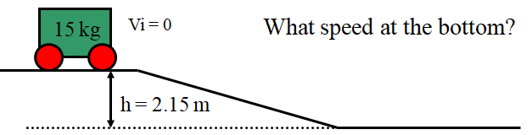(6.5 m/s)

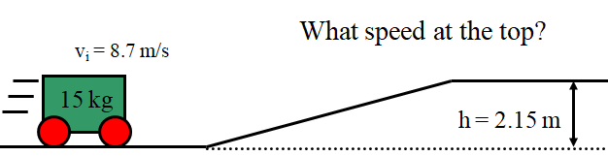 (5.8 m/s)

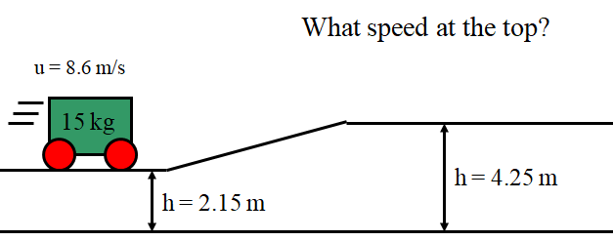 (5.7m/s)

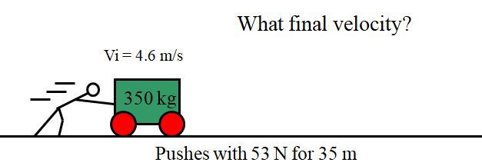 (5.6 m/s)

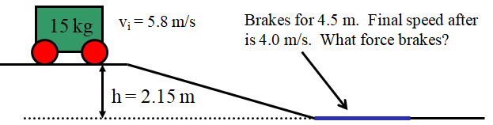(99.6 N)

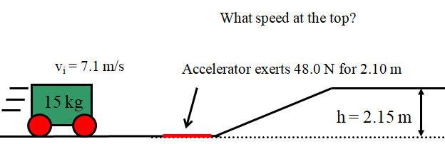 (4.66 m/s)
Quizlette 5.2.2 - Conservation of Energy with Words Name

Fd + mgh + ¹/₂mv² = Fd + mgh + ¹/₂mv²
1 → 1 problems:
1) If you exert 15.0 N vertically upward a distance of 0.850 m on a 0.145 kg baseball, to what height above the starting point will it rise? Neglect friction, and assume the baseball was initially motionless.

2) A 2130 kg car coasts from rest down a small hill that is 2.40 m tall. What is the velocity of the car at the bottom? Neglect friction

3) A 0.440 kg hammer going 9.60 m/s horizontally strikes a nail, driving it into a wall 2.70 mm (0.00270 m) What force did it exert on the nail?

1) 8.97 m, 2) 6.86 m/s, 3) 7509 N, 4) 8.11 m/s, 5) 2.64 m, 6) 0.445 N

2 → 1 or 1 → 2 problems:
4) A 23.0 kg cart is going 5.70 m/s at the top of a 1.70 m tall hill. What speed does it have at the bottom?
Neglect friction

5) A 53.0 kg cart already going 4.20 m/s is given a forward push with a force of 82.0 N for a distance of
11.0 m. It then rolls up a hill. To what height will it roll before stopping? Neglect friction

6) A 0.113 kg pine cone falls from a height of 5.60 m. It strikes the ground at 8.10 m/s. What was the
average force of air friction slowing the pine cone as it fell?

Fd + mgh + ¹/₂mv² = Fd + mgh + ¹/₂mv²
2 → 2 problems:
7) 7.44 m/s, 8) 7.32 m/s, 9) 723 N

7) A 12.0 kg cart is going 3.50 m/s on top of a 4.50 m tall hill. What is its speed on top of a 2.30 m tall
hill? Neglect friction

8) A 26.0 kg kid sledding down a 2.70 m tall hill from rest gets a push of 78.0 N for 3.70 m. What is their speed when they are at an elevation of 1.10 m? Neglect friction

9) A 45.0 kg cart going 6.20 m/s on the top of a 4.10 m tall hill is slowed at the bottom with by a braking force over a distance of 2.30 m until it is going only 6.70 m/s. What is the braking force?

In the space below, draw a cartoon of Mr. Duggan and Mr. Osborn firing air rockets from hip level at
a hapless Mr. Jukkula dressed as a happy clown.

Physics
FA5.2 - Conservation of Energy
Name

Favorite Palindrome

Show your work, and circle your answers to receive full credit.
1. Rosa Boat exerts 1.20 N of force for 0.135 m on a 0.345 kg air track glider that is initially at rest. What is its final velocity? (assume the air track is level)

2. Shirley Nott sets up an air track so the left side is higher than the right. If a 0.345 kg glider starts at rest on the left side, and is going 0.686 m/s when it reaches the right side, what is the change in height from left to right?

3. A 3.40 kg bowling ball hanging from the ceiling on a long string swings from side to side like a pendulum. When it is at rest 15.0 cm above its lowest point on the left side, I shove it from rest with a force of 11.0 N for a distance of 0.350 m in the direction it is going. How high will it swing on the other side? (Neglect friction)

4. A 580. kg rollercoaster car is going 7.50 m/s on the top of a 1.20 m tall hill, how fast is it going on top of a 3.50 m tall hill? (Neglect friction)

Conservation of Energy Questions from A5.2 (optional)
24.7 m  27.6 N  11.3 m/s  7.10 m/s | 1. a. A 0.145 kg baseball going 22.0 m/s straight up goes how high before stopping?  b. A baseball pitcher speeds a 0.145 kg ball from rest to 38.0 m/s over a distance of 3.80 m. What must be the average force exerted on the ball? (Neglect friction or any change in elevation)  c. A 1340 kg car is moving at some speed at an elevation of 5.50 m partway up a hill, and then coasts to a stop at an elevation of 12.0 m. How fast was it going at 5.50 m elevation? (Neglect friction)  d. A 150. kg sled is going 3.40 m/s at the top of a 2.50 m tall hill. At the bottom it hits a patch of dirt that exerts a slowing force of 180. N for 4.20 m. How fast is the sled going after the dirt patch? (Neglect friction)
89.7 N  9.44 m  178 N  2.41 m | 2. a. A 0.320 kg hammer is going 8.20 m/s. What force would stop it in 0.120 m?  b. A 1530 kg car starts at rest and rolls down a hill. At the bottom it is going 13.6 m/s. How high was the hill? (Neglect friction)  c. Mom gives 55.0 kg Tamara a push from rest on her massless sled for a distance of 7.20 m at the top of a 3.80 m tall hill. If she is going 11.0 m/s at the bottom of the hill, what force did Mom exert at the top to speed her up? (Neglect friction)  d. A 410. kg rollercoaster car going 3.40 m/s hits an accelerator that exerts a force of 780. N to speed up the car over a distance of 14.0 m. The car then rolls up a hill where it is going 4.20 m/s. What is the height of the hill? (Neglect friction)
1.71 m/s  10.5 m  9.40 m/s  3.99 m | 3. a. A 5.00 kg pendulum starts from rest 0.150 m above the lowest point. What is its speed when it reaches the lowest point?  b. A 0.170 kg ball is sped up with a 5.00 N force straight up from rest a vertical distance of 3.50 m. To what height does it rise above its lowest point before stopping? (Neglect air friction)  c. A 0.170 kg ball is sped up with a 5.00 N force straight up from rest a vertical distance of 3.50 m. What is the velocity of the ball when it is a height of 6.00 m above its lowest point? (Neglect friction)  d. A 784 kg rollercoaster car is going 7.50 m/s at the top of a 2.15 m tall hill. At what height is it when it is going 4.50 m/s? (Neglect friction)
1.40 N  25.6 m  8.91 m/s  1.81 m | 4. a. What force over 0.180 m exerted on a 0.345 kg air track glider speeds it from rest to 1.21 m/s?  b. A 0.145 kg baseball is popped straight up, and goes 33.5 m in the air before coming back down. What was its initial velocity? (Neglect friction)  c. A 1370 kg car going 14.7 m/s on a level road strikes a puddle that exerts a retarding force of 5200. N What is the velocity of the car when it has gone 18.0 m into the puddle?  d. A 680. kg Rollercoaster car at rest on top of a 3.50 m tall hill is sped up by a force of 7780 N for a distance of 2.50 m. What is the height of the car when it is going 9.50 m/s? (Neglect friction)
9.29 m/s  0.219 m  0.592 m  5.07 m/s | 5. a. A 65.0 kg sled starts from rest at the top of a 4.40 m tall hill. What is its speed at the bottom of the hill? (Neglect friction)  b. Ferdinand exerts a force of 168 N for a distance of 18.5 m on the level speeding up a 1450 kg car initially at rest. The car then rolls up an incline. How much elevation will the car gain before it stops? (Neglect friction)  c. Reginald exerts a force of 195 N for a distance of 35.0 m on the level speeding up a 985 kg car from rest. The car then rolls up an incline. What elevation has the car gained when it has a velocity of 1.50 m/s? (Neglect friction)  d. A 450. kg roller coaster car initially at rest is launched from the top of a 2.30 m tall hill by a 4890 N force exerted over a distance of 3.80 m. What is the speed of the car when it is at the top of a 5.20 m tall hill? (Neglect friction)

