Friction Noteguide:
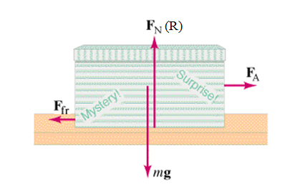
Friction - Force needed to drag one object across another. (At a constant velocity):

Depends on:

Not supposed to depend on:

Table from the book: (Some books call kinetic friction "dynamic")
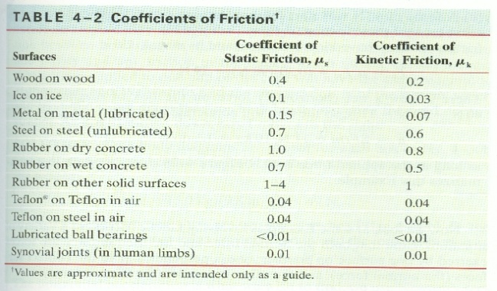

Kinetic Friction - Force needed to keep it going at a constant velocity. (AKA Dynamic friction)
F_{F} = μ_{k}F_{N}
Always in opposition to velocity (direction it is sliding)

Static Friction - Force needed to start motion.
F_{F} < μ_{s} F_{N}
Keeps the object from moving if it can.
Only relevant when object is stationary.
Always in opposition to applied force.
Calculated value is a maximum
ABS systems in cars/Traction control

Sample Problem: A 5.00 kg block rests on a level table where there is a static coefficient of friction of 0.470, and a dynamic of 0.170.
a) What are the dynamic and maximum static forces of friction? (8.33 N, 23.03 N ≈ 23.0 N)

b) if it is at rest and you exert a force of 12.0 N sideways on it what happens? (draw a diagram, understand)

c) if it is at rest and you exert a force of 35.0 N to the right on it, what is the acceleration of the block? (+5.33 m/s/s)

d) If it is sliding to the right and you exert a force of 7.50 N to the left, what is the acceleration of the block? (-3.17 m/s/s)

e) If it is sliding to the right, but decelerating at 0.950 m/s/s, what force besides friction must be acting on the block? (+3.58 N)

f) If it is sliding to the left and decelerating at 1.20 m/s/s, what other force besides friction must be acting on the block? (-2.33 N)

