Noteguide for Finding Vector Components - Videos 3B Name

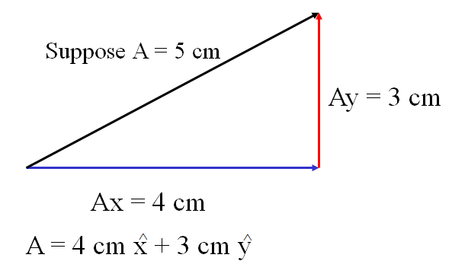

Try to write these AM vectors as Component Vectors. Decide which side is x and which is y, which are negative, which are positive. Write it like I showed you in the previous part. Watch the videos to check your answers.
1. 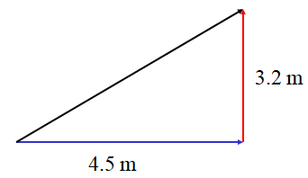 | 2. 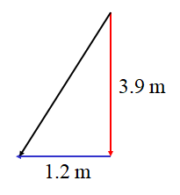
3. 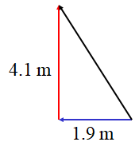 | (Draw a cartoon here)

Finding the lengths of the sides
(Get your calculator out and calculate the things I do)
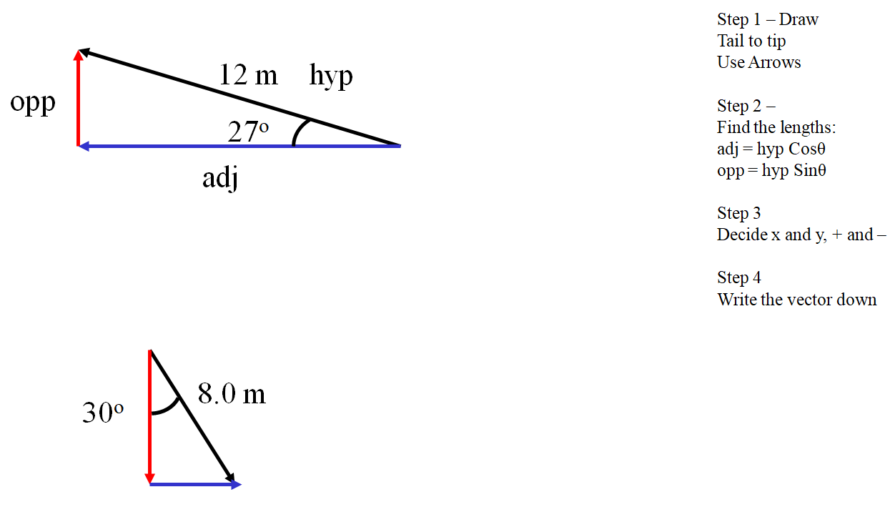

Try this one yourself:

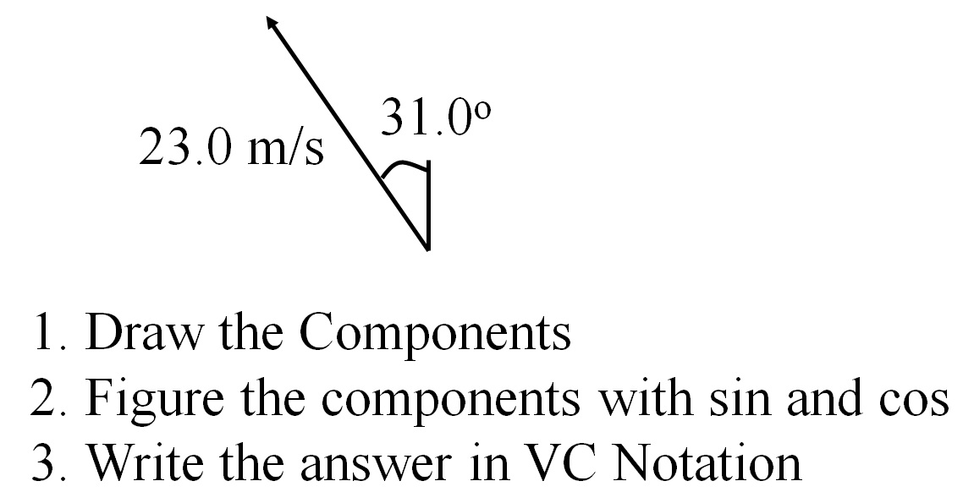

-11.8 m/s x + 19.7 m/s y (the x and the y should have little ^ hats on them ; - )

