More Graph Matching 2 Names ,
Bonus Graph Set: Can you match this set of graphs? Describe the motion of the cart. (Hint – use the gray cart with the spring plunger):
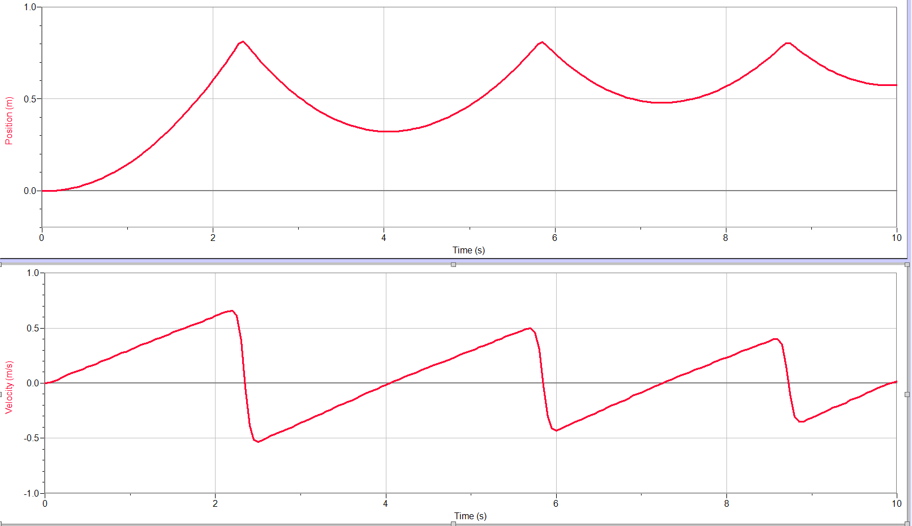
Description of motion:

