Tualatin High School Presents a

At Tualatin High School, Tuesday, May 24th in the Main Commons
Student Demonstrations 6:00-7:00
Rhys Thomas 7:15 –8:15
(Juggler Extraordinaire)

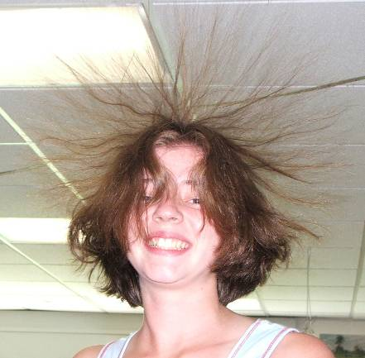

It’s Fun, AND it’s Educational
(It’s even a bit Extravagant)
Appropriate for all ages

See Student Demonstrations on Resonance, Fire Balls, Electrostatics, Inertia, Harmonographs, Waves, Fluid Mechanics,
Chromatography, Angular Momentum, Conservation of Energy, Stroboscopy, Pressure, and Combustion

and Best of all –

It’s Free

