Tualatin High School Presents a

At Tualatin High School, Thursday, May 23rd in the Main Commons
Student Demonstrations 6:00-7:00
Rhys Thomas 7:15 –8:15
(Juggler Extraordinaire)

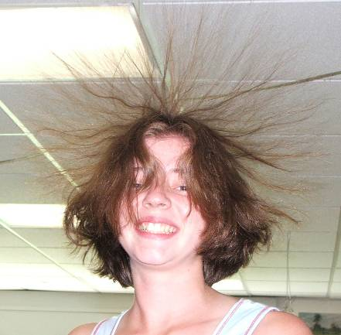

It’s Fun, AND it’s Educational
(It’s even a bit Extravagant)
Appropriate for all ages

See Student Demonstrations on Resonance, Fire Balls, Electrostatics, Inertia, Harmonographs, Cryogenics, Optical Illusions, Waves, Pressure, Strobe Lights, Buoyancy, Non-Newtonian fluids, and many more.

and Best of all –

It’s Free

