Tigard and Tualatin High Schools Present a

Physics Extravaganza

At Tualatin High School, Thursday, May 21st
Student Demonstrations 6:00-7:00 in the Main Commons
Rhys Thomas 7:30 –8:30 in the Auditorium
(Juggler Extraordinaire)
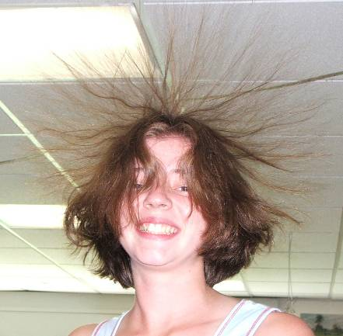

It’s Fun, AND it’s Educational
(It’s even a bit extravagant)
Appropriate for all ages

See Student Demonstrations on Resonance, Fire Balls, Van de Graaff Generators, Inertia, Harmonographs, Cryogenics, Optical Illusions, Waves, Pressure, Strobe Lights, Buoyancy, Oobleck and many more.

and Best of all –

It’s Free

