Tigard and Tualatin High Schools Present a

Physics Extravaganza

At Tualatin High School, Tuesday, May 29th
Student Presentations 6:00-7:00 in the Main Commons
Juggling with Rhys Thomas 7:30 –8:30 in the Auditorium
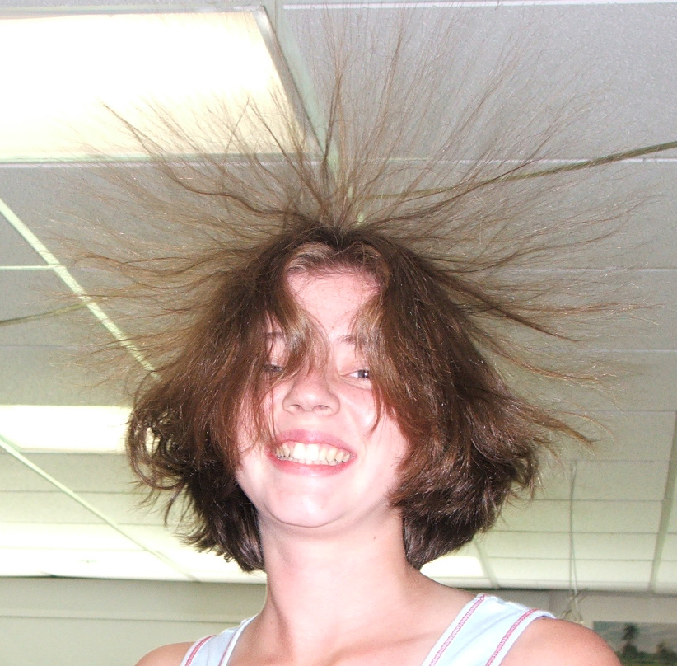

It’s Fun, AND it’s Educational
(It’s even a bit extravagant)
Appropriate for all ages

See Demonstrations on Zero Gravity, Fire Balls, Van de Graaff Generators, Inertia, Harmonographs, Cryogenics, Vortices, Optical Illusions, Waves, Pressure, Strobe Lights, Projectile Motion, Buoyancy, Oobleck and many more.

See the Magic that is Rhys Thomas – Teacher/Maestro/Juggler

and Best of all –

It’s Free

