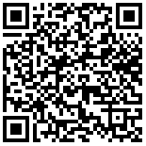
Dear IB Physics Parents and Community:
This is your cordial invitation to the 32nd annual Tualatin Physics research symposia. They will be held at 7:00-9:00 on the evenings of Tuesday, February 28th, Wednesday, March 1st and Thursday March 2nd in the lecture hall of Tualatin High School. (Enter on the North side near the flag pole) Check the link in the QR code above to see which night your scientist is presenting. I will also send this to your email, and put a link there as well.
The purpose of the symposia is for my students to defend their semester research projects before the public (you). Their projects constitute one of their final examinations for the semester of IB Physics, and for the IB students, this is their Internal Assessment work.
These Symposia feature research on oscillating cantilevers, projectile motion (of various kinds), golf kinetics, bouncing balls, refraction, magnetic fields, viscosity, fluid mechanics, water wheels, resistivity, magnetic braking, and battery internal resistance.
Hope to see you there!!!
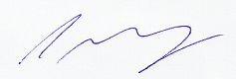
Chris Murray
Tualatin High School

