Noteguide for Energy and Climate Change:

Wind Power:
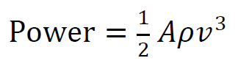

Ex – What max power can you get from a wind turbine with 8.2 m long blades when the wind speed is about 5.4 m/s on the average? Use the density of air to be 1.2 kg/m³
2.0E4 Watts

Try this one:
What total frontal area do you need to generate 240MW in an area that has an average wind speed of 6.5 m/s? Use the density of air to be 1.2 kg/m³. How many turbines with a radius of 35 m would you need to use in your array?
1.45E6m², about 379 turbines

Solar Power:
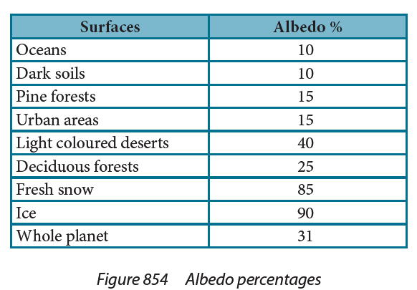
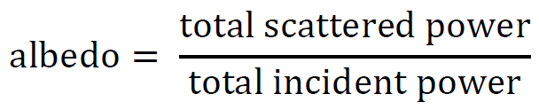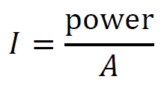

Ex – What is the power absorbed by a 235 m² patch of fresh snow when sunlight of intensity 1030 W/m² is shining straight down on the surface?
36kW

Try this one:
On a day when the solar constant is 1030 W/m², how much power per square meter is reflected off into space from the oceans? How much is absorbed?
103 W/m² 927 W/m²

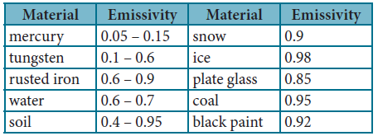
Radiant Heat Transfer:
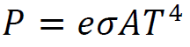

Ex – A person has a body surface temperature of about 35 ºC and is in a room where the walls are at 14 ºC. If they have a surface area 2.00 m², and an emissivity of 0.570, what is the rate of net heat lost to the room? (143 W)

Try this one:
A piece of freshly made glass (e = 0.85) at a temperature of 2600 K is placed in a oven at 1200 K. If it is initially losing heat at a rate of 5900 W, what is its area? (0.0028 m²)

Wien Displacement:

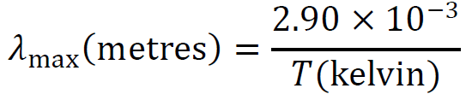

Ex: A star has a peak black body wavelength of 501 nm. What is its temperature? (5790 K)

What is the peak radiation of the surface of ocean water that is at 21.0 ºC?

