Problems from 27.2 - Atomic Physics

Closest Approach: 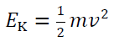 and 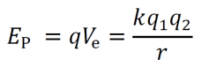 q₁ = 2e, q₂ = Ze
- An alpha particle (m = 6.64x10⁻²⁷ kg) going 5.14x10⁶ m/s will get how close to a silver (Z = 47) nucleus if it hits head on? (2.47x10⁻¹³ m)
- A speeding alpha particle (m = 6.64x10⁻²⁷ kg) hits a mercury (Z = 80) nucleus head on. If it comes within 17.0 nm of the nucleus’ center, how fast was it going to start with? (2.56x10⁴ m/s)
- An alpha particle (m = 6.64x10⁻²⁷ kg) going 4.12x10⁶ m/s will get how close to a bismuth (Z = 83) nucleus if it hits head on? (6.80x10⁻¹³ m)
- A speeding alpha particle (m = 6.64x10⁻²⁷ kg) hits a lead (Z = 82) nucleus head on. If it comes within 12.0 nm of the nucleus’ center, how fast was it going to start with? (3.08x10⁴ m/s)
- An alpha particle (m = 6.64x10⁻²⁷ kg) going 2.37x10⁶ m/s will get how close to a gold (Z = 79) nucleus if it hits head on? (1.95x10⁻¹² m)

Electron Transitions: 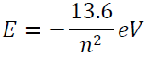 and 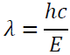
- What is the wavelength of the photon associated with an electron transition from n = 3 to n = 1 in a hydrogen atom? Is the photon being absorbed, or emitted? (103 nm, emitted)
- What is the wavelength of the photon associated with an electron transition from n = 3 to n = 6 in a hydrogen atom? Is the photon being absorbed, or emitted? (1095 nm, absorbed)
- What is the wavelength of the photon associated with an electron transition from n = 2 to n = 1 in a hydrogen atom? Is the photon being absorbed, or emitted? (122 nm, emitted)
- What is the wavelength of the photon associated with an electron transition from n = 2 to n = 4 in a hydrogen atom? Is the photon being absorbed, or emitted? (487 nm, absorbed)
- What is the wavelength of the photon associated with an electron transition from n = 6 to n = 2 in a hydrogen atom? Is the photon being absorbed, or emitted? (411 nm, emitted)

Nuclear Radius or Heisenberg: 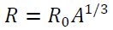 or 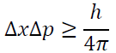 or 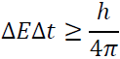
- What is the radius of C-14 nucleus? (2.89x10⁻¹⁵ m)
- What is the likely mass number of a nucleus with a radius of 3.51x10⁻¹⁵ m? (25)
- To effect an alpha decay, an alpha particle must “borrow” 31.1 MeV of energy. What time does it have to escape? (1.06x10⁻²³ s)
- An Alpha particle takes 1.80x10⁻²³ s to "tunnel" through a potential barrier. What is the amount of energy it can "borrow" during this time in MeV? (18.3 MeV)
- An electron has an uncertainty in its velocity of ±2.10x10⁴ m/s. What is the minimum uncertainty in its position? (1.38x10⁻⁹ m)
- An electron has an uncertainty in its position of 2.40x10⁻¹⁰ m (total range) . What is the minimum uncertainty (the total range) of its velocity? (2.41x10⁵ m/s)
- A proton has an uncertainty in its position of 3.51x10⁻¹⁵ m (total range). What is the minimum uncertainty (the total range) of its velocity? (8.98x10⁶ m/s)
- A proton has an uncertainty in its velocity of ±4.30x10⁶ m/s. What is the minimum uncertainty in its position? (3.66x10⁻¹⁵ m)

Part A: Find the missing particle:
 | a | b | c | d
1 | τ⁻ → π⁻ + πº + ??  υ_{τ} | ?? → π⁺ + πº + $\overline{{}_{τ}}$  τ⁺ | τ⁻ → υ_{τ} + ?? + $\overline{{}_{e}}$  e⁻ | τ⁺ → $\overline{{}_{τ}}$ + e⁺ + ??  υ_{e}
2 | τ⁻ → ?? + μ⁻ + $\overline{{}_{μ}}$  υ_{τ} | τ⁺ → ?? + μ⁺ + υ_{μ}  $$\overline{{}_{τ}}$$ | ?? → e⁻ + $\overline{{}_{e}}$ + υ_{μ}  μ⁻ | μ⁺ → e⁺ + ?? + $\overline{{}_{μ}}$  υ_{e}
3 | μ⁻ → e⁻ + $\overline{{}_{e}}$ + υ_{μ} + e⁺ + ??  e⁻ | μ⁺ → e⁺ + ?? + $\overline{{}_{μ}}$ + e⁺ + e⁻  υ_{e} | $K_{L}^{o}$ → π⁺ + ?? + $\overline{{}_{μ}}$  μ⁻ | K⁺ → ?? + υ_{μ}  μ⁺

Part B: For these reactions, indicate if it is possible, or indicate every law it violates:
 | a | b | c | d
1 | p + n → K⁺ + ηº + Ξº  No, baryon number, Strangeness | p + n → p + $\overline{p}$ + $\overline{n}$  No, charge and baryon number | n + n → Λº + Σº  No, Strangeness | n + n → Ω⁺ + Ω⁻  No, baryon number
2 | p + p → Ω⁺ + e⁺ + Λº + Σº + n  No, Le, Strangeness | p + p → p + n + n + Ω⁺  No, Strangeness | p + p → τ⁺ + υ_{τ} + μ⁺ + $\overline{υ_{μ}}$  No, Baryon and Lμ | p + n → n + n + τ⁺ + υ_{τ}  Yes
3 | p + $\overline{p}$ → τ⁻ + Λº + Ω⁺ + $\overline{υ_{τ}}$  No, Strangeness | p + $\overline{n}$ → τ⁺ + τ⁻  No, charge | $\overline{n}$ + n → τ⁺ + τ⁻  Yes | p + $\overline{p}$ → Σ⁻ + Ω⁺  No, Strangeness
4 | p + p → p + p + πº  yes | p + p → p + n + π⁺  yes | n + n → Ξ⁺ + $\overline{{}^{o}}$+ Ω⁻ + n + n + n  yes | π⁻ + p → πº + n + π⁻ + π⁺  yes

Part C: Write the quark combinations that make up a proton and a neutron: p = n =
Identify the following quark combinations as either a meson, or a baryon. Determine the baryon number, strangeness, and the charge of each:
 |  | Baryon or Meson? | B = ? | S = ? | 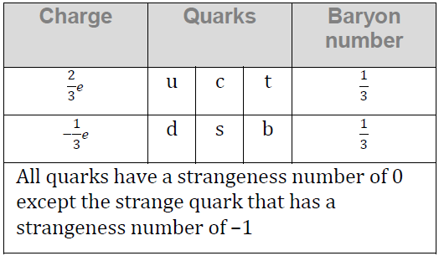  q = ?
1 | s$\overline{s}$ | M | 0 | 0 | 0
2 | dsc | B | +1 | -1 | 0
3 | $$\overline{u}\overline{u}\overline{u}$$ | B | -1 | 0 | -2
4 | s$\overline{u}$ | M | 0 | -1 | -1
5 | d$\overline{s}$ | M | 0 | +1 | 0
6 | sss | B | +1 | -3 | -1  Data Packet reference for decays:
7 | $$\overline{u}\overline{u}\overline{c}$$ | B | -1 | 0 | 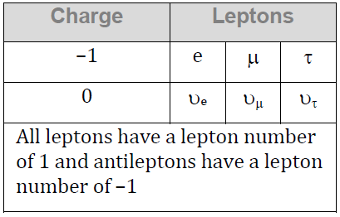  -2
8 | u$\overline{s}$ | M | 0 | +1 | +1
9 | c$\overline{d}$ | M | 0 | 0 | +1
10 | $$\overline{s}\overline{s}\overline{c}$$ | B | -1 | +2 | 0
11 | ucc | B | +1 | 0 | +2
12 | s$\overline{b}$ | M | 0 | -1 | 0

