Noteguide for Quark Theory - Videos 32E Name
Quark Theory:

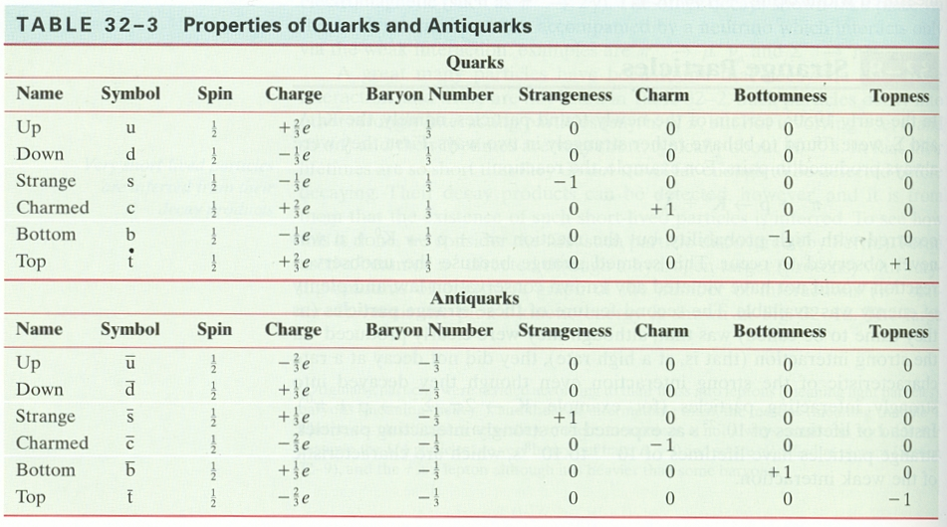

Baryons are (qqq)
B S q

p =

n =

Λº =

Mesons are (q$\overline{q}$)
B S q

π⁺ =

πº (u$\overline{u}$) =

η_{c} =

Whiteboards:
 |  | Baryon or Meson? | B = ? | S = ? | 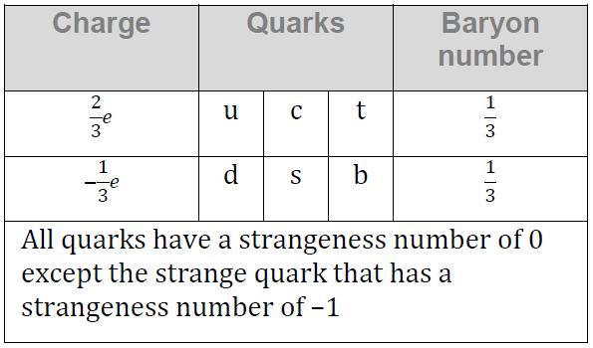  q = ?
1 | usc
2 | u$\overline{s}$
3 | ddc
4 | d$\overline{s}$

