Noteguide for Balancing Nuclear Reactions- Videos 30M Name

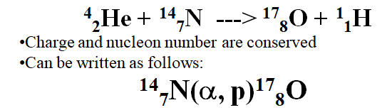
Initial Nucleus(bombarding particle, emitted particle)Final Nucleus

Common Particles you should know:

α = ⁴₂He, p = ¹₁H, d(deuterium) = ²₁H, t(tritium) = ³₁H, ¹₀n = neutron, ⁰₀ γ = gamma

Exoergic means:

Endoergic means:

Example:
What is the initial nucleus:
??? + n ---> p + ¹⁴₆C

Whiteboards: - Find the missing nucleus
¹³⁷₅₆Ba (n , γ) ???

(¹³⁸₅₆Ba)
¹³⁷₅₆Ba (n , ???) 137₅₅^{Cs}

(p = ¹₁H)
²₁H (d , ?) ⁴₂He

(γ )
¹⁹⁷₇₉Au (α , d) ???

(¹⁹⁹₈₀Hg)
⁹₄Be (??? , t) ⁸₄Be

(²₁d)

