**Noteguide for Activity and Half Life - Videos 30IJK Name**

**Videos 30I:**

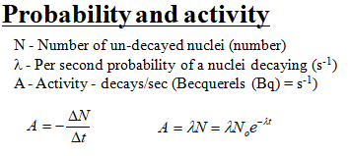Example - Radon 222 has an atomic mass of 222.02. How many grams of it do you have if your activity is 8.249x1016 decays/sec, and your decay probability is 2.098x10-6 s-1? N­A = 6.02x1023 atoms/mol

Whiteboards:

|  |  |
| --- | --- |
| What is the activity if you have a λ of 3.19x10-10 s-1, and you have 5.12x1023 un-decayed nuclei?  (1.63x1014 decays/sec) | What is the λ if 1.27x1020 un-decayed nuclei generate 1420 decays per second?  (1.12x10-17 s-1) |

**Videos 30J:**

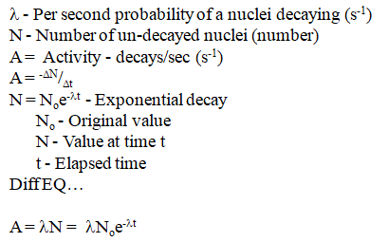

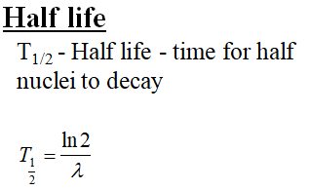

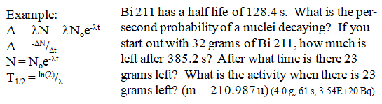

Whiteboards:

|  |  |
| --- | --- |
| 1. Oregonium has a decay probability of 8.91x10-8 s-1. What is its half life in days? (90 days) | 2. What is the nuclear decay probability of a substance that has a half life of 96.23 minutes?  (0.0001201 s-1) |
| 3. Oregonium has a decay probability of 8.91x10-8 s-1. If you have 1250 grams of Oregonium initially, how many grams do you have after 30.00 days? (x24x3600) (992 g) | 4. Tualatonium has a half life of 12 seconds. If you start with 64 grams of it, how much remains after a minute? (Cheat) (2.0 g) |
| 5. Tigardium has a half life of 8.34 seconds. The initial activity is 1350 counts/second, after what time is the activity 125 counts/sec? (28.6 s) | 6. A certain substance has an activity of 1245 counts/sec initially, and an activity of 938 counts/second after exactly 3.00 minutes. What is the half life of the substance? (441 s) |

**Video 30K:** Radiometric Dating

So - go read the account of Clair Patterson: https://en.wikipedia.org/wiki/Clair_Cameron_Patterson

(You won't believe it)