Noteguide for Beta and Gamma Decay- Videos 30GH Name

Video 30G:
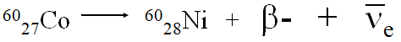

Conservation of charge
Beta minus - electron
“As if” neutron -> proton + electron
Beta plus - positron
“As if” proton -> neutron + positron
Particles are “of the nucleus” (not orbital)
- - Neutrino, (anti neutrino) – fudge
Energy is continuous (i.e. neutrino gets random share)

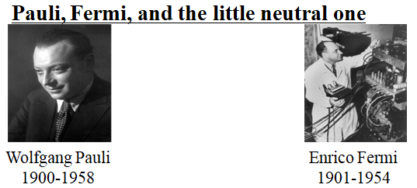

Beta decay products were missing energy
Pauli proposes a particle is carrying away energy
Fermi names it Neutrino - “Little neutral one” - It.
Neutrinos confirmed in 1956, no surprise

Videos 30H:
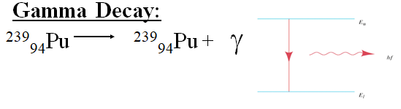
Nucleus has energy levels
Energy of transition emitted as a high energy photon (λ ≈ 5 - .05 nm)
Usually after a beta or alpha decay
Many energies possible
Stopped by meters of lead
Used for food irradiation

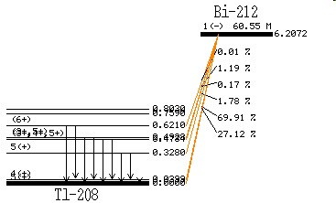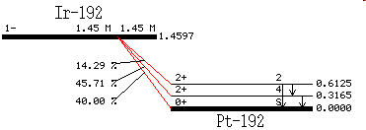

Gamma ray energies associated with alpha and beta decays – so Alpha and Gamma energies are discrete. (Like spectral lines we saw)

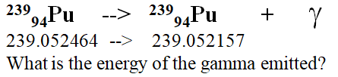

Whiteboards:
Tl-208 emits a 0.6210 MeV gamma and the neutral atom in the unexcited state has a mass of 207.9820047 u. What was the mass of the excited state before the gamma was emitted?
(207.9826714 u)

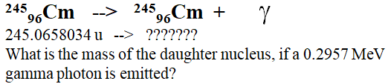 (245.065486 u)

