Noteguide for Alpha Decay and Tunneling- Videos 30EF Name
Videos 30E:
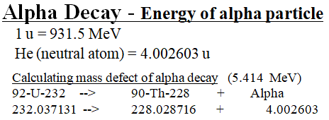

Why Alpha Decay:
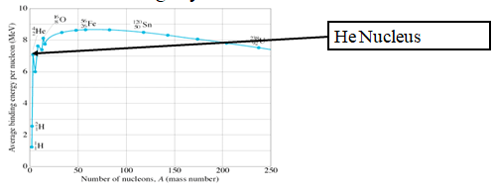

Whiteboards:
Find the energy of this Alpha Decay in MeV:
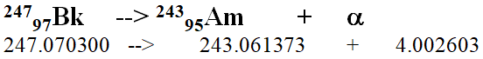

Find the energy of this Alpha decay in MeV, Joules, and calculate the velocity of the particle given the mass of an alpha particle is 6.64x10⁻²⁷ kg
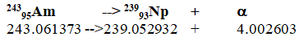

Videos 30F:

