**Noteguide for Copenhagen and Heisenberg - Videos 27MNO Name**

**27M:**

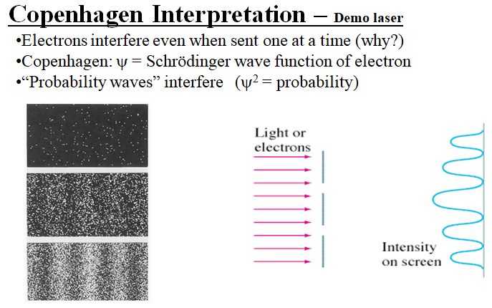

**27N: Heisenberg** – The more accurately you know an object’s position, the less accurately you can know its momentum because observing tiny things like electrons changes their momentum, and resolution is on the order of the wavelength of the photon you use.

Key formula:  Small λ = large p, Large λ = small p

Observing an electron with a small wavelength:

Observing an electron with a large wavelength:

|  |  |
| --- | --- |
| Momentum-position:    Δx = Range of position (m)  Δp = Range of momentum (kg m/s)  h = Planck’s Constant (6.626x10-34 Js) | Energy-time    ΔE = Range of energy (J)  Δt = Range of time (s)  h = Planck’s Constant (6.626x10-34 Js) |

Example 1: What is the uncertainty in the position of a 0.145 kg baseball with a velocity of 37.0 ± 0.3 m/s?

Example 2: An electron stays in the first excited state of hydrogen for a time of approximately Δt = 1.0 x 10-10 s

Determine the uncertainty in the energy of the electron in the first excited state.

Whiteboards

|  |  |
| --- | --- |
| 1. What is the uncertainty of the energy of an electron for an interval of 2.1x10-16 s?  (ΔE = 2.5 x 10-19 J) | 2. To effect an alpha decay, an alpha particle must “borrow” 27.0 MeV of energy. What time does it have to escape?  27.0 MeV = (27.0x106 eV)(1.602x10-19 J/eV)  (Δt =1.22 x 10-23 s) |
| 3. You know an electron’s position is ±0.78 nm, what is the minimum uncertainty of its velocity?  (v = 3.7 x 104 m/s) | 4. A proton has an uncertainty in its velocity of 5.20x106 m/s. (That’s the total range) What is the minimum uncertainty in its position?  (Δx = 6.06 x 10-15 m) |

**270:** The Einstein Bohr Debate:

Einstein objected to: Famous Einstein Quote:

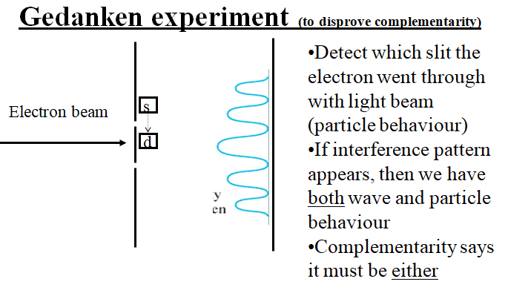

(Why this experiment would not work:)